**DUY TAN UNIVERSITY  
INTERNATIONAL SCHOOL**

*******************



**PROJECT DOCUMENT**

**SIMULATE DEFENSE AND ATTACK**

**IN THE NETWORK MODEL**

**COURSE:** **CMU-CS 428 - CLASS: SAIS**

**HACKING EXPOSED**

**SUMMER TERM – YEAR 2023-2024**

**GROUP NO.3 -** Group members:

|  |  |  |
| --- | --- | --- |
| Tran Van Duc | 27211101110 | Team Leader |
| Chu Van An | 27211100910 | Member |
| Pham Ho Anh Dung | 27211100253 | Member |
| Luong Vu Anh Nga | 27201101324 | Member |
| Tran Thi Thanh Thuy | 27201248708 | Member |
| Đặng Ngọc Xuân Trí | 27211141704 | Member |

**Instructor:** MSc, Thuan, Nguyen Trung

Submission Date: 17-07-2024

|  |  |
| --- | --- |
| **DUY TAN UNIVERSITY** | **PROJECT DOCUMENT** |
| **INTERNATIONAL SCHOOL** | **COURSE: CMU-CS 428 - CLASS: SAIS** |
|  | **Summer Term – Year 2023-2024** |

**GROUP NO.: 3 -** Group members:

|  |  |  |
| --- | --- | --- |
| Tran Van Duc | 27211101110 | Team Leader |
| Chu Van An | 27211100910 | Member |
| Pham Ho Anh Dung | 27211100253 | Member |
| Luong Vu Anh Nga | 27201101324 | Member |
| Tran Thi Thanh Thuy | 27201248708 | Member |
| Đặng Ngọc Xuân Trí | 27211141704 | Member |

**TOPIC: SIMULATE DEFENSE AND ATTACK IN THE NETWORK MODEL**

TABLE OF CONTENTS

PART1: OVERVIEW 1

1.1 Introduce 1

1.2 Goal: 1

PART2: SETTING UP THE EXPERIMENTAL ENVIRONMENT 2

2.1 Implementation Diagram: 2

2.2 Install DNS server 3

2.2.1 install dns1 server 3

2.2.1.1 Configuring network for Primary Server – DNS1 3

2.2.1.2 Installing BIND in DNS1 4

2.2.1.3 Configuring Primary DNS Server (DNS1) 4

2.2.2 install dns2 server 7

2.2.2.1 Configuring network for Secondary Server – DNS2 7

2.2.2.2 Installing BIND in DNS2 8

2.2.2.3 Configuring Secondary DNS Server (DNS2) 8

2.3 Installing wireshark 9

2.4 Install Firewall Pfsense 13

2.5 Install SIEM 23

2.5.1 install ELK 23

2.5.2 Install ElasticSearch 24

2.5.3 Install Kibana 26

2.5.4. Install Logstash 27

2.6 Install WebServer 33

PART3: ATTACK SCENARIO AND DEMO 39

PART4: ANALYZE AND IDENTIFY VULNERABILITIES 43

4.1 Analysis static wireshark 43

4.1.1 ICPM packet analysis 43

4.1.2 TCP packet analysis 47

4.1.3 HTTP Protocol Analysis 49

4.2 Python + Wireshark Automated Analysis 53

4.3 Detect traffic attacks. 55

4.3.1 XSS (Cross-Site Scripting) Attack Detection. 55

4.3.1 SQL injection attack detection: 56

PART5: PROPOSE SOLUTIONS AND REMEDIES. 58

PART6: CONCLUDE 59

PART 7: REFLECTION 60

ADDENDUM 61

PART1: OVERVIEW

1.1 Introduce

The development of information technology brings many great benefits, but it also entails many worrying problems. Problems related to users, data theft, phishing, attacks on systems lead to serious consequences.

The experimentation and research from attack methods and experiments in environments to analyze and come up with security solutions to overcome vulnerabilities, prevent and reduce vulnerabilities that may occur.

1.2 Goal:

Deploy the actual network model to perform test attacks.

Analyze the cause of the attack based on logs and traffic left behind to find the cause and provide a solution.

PART2: SETTING UP THE EXPERIMENTAL ENVIRONMENT

2.1 Implementation Diagram:

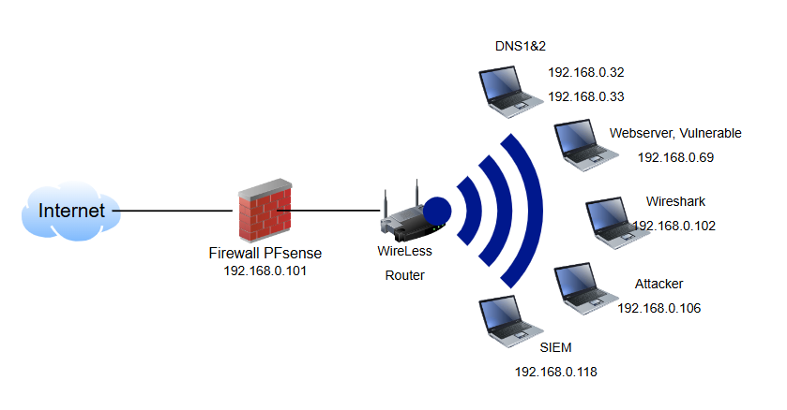

**Description:** Implement the above network diagram for security testing, network management and monitoring, research on cyberattacks, and defensive measures.

Internet: Connect from an external network.

Chu Van An implements PFSense Firewall: the firewall uses PFSense software. It protects the internal network from external threats and manages network traffic.

Wireless Router: A wireless router connects to a firewall and provides a Wi-Fi network to devices in the local network. This router connects to devices via Wi-Fi waves.

Luong Vu Anh Nga implements NDS1 & DNS2 (192.168.32 and 192.168.33): takes on the role of DNS server.

Pham Ho Anh Dung implemented Webserver, Vulnerable (192.168.0.69): A web server with security vulnerabilities, which can be used for security testing or research.

Tran Van Duc implements Wireshark (192.168.0.102): The computer runs Wireshark, a network packet analysis tool, to monitor and analyze network traffic.

Dang Ngoc Xuan Tri performs Attacker (192.168.0.104): The attacker's computer, used to carry out attacks on the system, is often used in a test environment.

Nguyen Thi Thanh Thuy implements SIEM (192.168.0.118): Security Information and Event Management System (SIEM), used to monitor and manage security events on the network.

2.2 Install DNS server

2.2.1 install dns1 server

IP addresses information table

|  |  |  |
| --- | --- | --- |
| Host | FQDN | IP Address |
| dns1 | dns1.cs428.vn | 192.168.0.32 |
| dns2 | dns2.cs428.vn | 192.168.0.33 |
| web | web01.com | 192.168.0.69 |

2.2.1.1 Configuring network for Primary Server – DNS1

**Editing network configuring file: /etc/netplan/00-installer-config.yaml**

|  |
| --- |
| network:  ethernets:  ens33:  addresses: [192.168.0.32/24]  routes:  - to: default  via: 192.168.0.1  nameservers:  search: [dtu.cs428.edu, cs428.edu, cs428.vn]  addresses: [192.168.0.27,192.168.0.28,8.8.8.8,8.8.4.4]  version: 2 |

- 192.168.0.32/24 is the ip address of DNS1

- Restart networking: netplan apply

**Editing /etc/hosts file**

|  |
| --- |
| 127.0.0.1 localhost  # The following lines are desirable for IPv6 capable hosts  ::1 ip6-localhost ip6-loopback  fe00::0 ip6-localnet  ff00::0 ip6-mcastprefix  ff02::1 ip6-allnodes  ff02::2 ip6-allrouters  192.168.0.32 dns1.cs428.vn dns1 |

2.2.1.2 Installing BIND in DNS1

- Getting updating

apt-get -y update

- Cài đặt gói BIND

apt-get -y install bind9 bind9utils bind9-doc

2.2.1.3 Configuring Primary DNS Server (DNS1)

**Change some information in the file name.conf.options**

nano /etc/bind/named.conf.options

|  |
| --- |
| acl "trusted" {  192.168.0.0/24;  };  options {  directory "/var/cache/bind";  recursion yes;  allow-recursion { trusted; };  listen-on { 192.168.0.32; };  allow-transfer { none; };  forwarders {  8.8.8.8;  8.8.4.4;  };    dnssec-validation auto;  auth-nxdomain no;  listen-on-v6 { any; };  }; |

- Identify trusted IP addresses that are allowed to access DNS

Subnet: 192.168.0.0/24

**Configuring Local DNS Zones**

nano /etc/bind/named.conf.local

- Adding forward zone for the domain com

|  |
| --- |
| zone "com" {  type master;  file "/etc/bind/zones/db.com";  allow-transfer { 192.168.0.33; }; |

- Adding reverse zone for the subnet 192.168.0.0/24

|  |
| --- |
| zone "0.168.192.in-addr.arpa" {  type master;  file "/etc/bind/zones/db.192.168.0";  allow-transfer { 192.168.0.33; };  }; |

- 192.168.0.33 is the ip address of DNS2

**Creating Forward Zone**

- Crreating the folder zones to save all files

mkdir /etc/bind/zones

- Creating file forward zones following /etc/bind/db.local

cp /etc/bind/zones/db.local /etc/bind/zones/db.com

- Editing file forward zone

nano /etc/bind/zones/db.com

|  |
| --- |
| $TTL 604800  @ IN SOA dns1.cs428.vn. admin.cs428.vn. (  3 ; Serial  604800 ; Refresh  86400 ; Retry  2419200 ; Expire  604800 ) ; Negative Cache TTL  ;  IN NS dns1.cs428.vn.  IN NS dns2.cs428.vn.  web01.com. IN A 192.168.0.69 |

- Adding nameservers (NS Record)

IN NS dns1.cs428.vn.

IN NS dns2.cs428.vn.

- Adding a record for web

web01.com. IN A 192.168.0.69

**Creating Reverse Zone**

- Creating reverse zone according to /etc/bind/db.127

Cp /etc/bind/zones/db.127 /etc/bind/zones/db.192.168.0

- Editing reverse zone

nano /etc/bind/zones/db.192.168.0

|  |
| --- |
| ; BIND data file for local loopback interface  ;  $TTL 604800  @ IN SOA dns1.cs428.vn. admin.cs428.vn. (  3 ; Serial  604800 ; Refresh  86400 ; Retry  2419200 ; Expire  604800 ) ; Negative Cache TTL  ;  ; name servers - NS records  IN NS dns1.cs428.vn.  IN NS dns2.cs428.vn.  ;  ; PTR Records  32 IN PTR dns1.cs428.vn. ; 192.168.0.32  33 IN PTR dns2.cs428.vn. ; 192.168.0.33  69 IN PTR web01.com. ; 192.168.0.69 |

- Adding nameservers (NS Record)

IN NS dns1.cs428.vn.

IN NS dns2.cs428.vn.

- Add a PTR record for web. The first column will be the last octet of the server's IP address.

**Checking syntax**

- For all files: named-checkconf

- Checking syntax in forward zone file:

named-checkzone cs428.vn /etc/bind/zones/db.com

- Checking syntax in reverse zone file:

named-checkzone 0.168.192.in-addr.arpa /etc/bind/zones/db.192.168.0

- Restart BIND: service bind9 restart

2.2.2 install dns2 server

IP addresses information table

|  |  |  |
| --- | --- | --- |
| Host | FQDN | IP Address |
| dns1 | dns1.cs428.vn | 192.168.0.32 |
| dns2 | dns2.cs428.vn | 192.168.0.33 |
| web | web01.com | 192.168.0.69 |

2.2.2.1 Configuring network for Secondary Server – DNS2

Editing network configuring file: /etc/netplan/00-installer-config.yaml

|  |
| --- |
| network:  ethernets:  ens33:  addresses: [192.168.0.33/24]  routes:  - to: default  via: 192.168.0.1  nameservers:  search: [dtu.cs428.edu, cs428.edu, cs428.vn]  addresses: [192.168.0.27,192.168.0.28,8.8.8.8,8.8.4.4]  version: 2 |

- 192.168.0.33/24 is the ip address of DNS2

- Restart networking: netplan apply

**Editing /etc/hosts file**

|  |
| --- |
| 127.0.0.1 localhost  # The following lines are desirable for IPv6 capable hosts  ::1 ip6-localhost ip6-loopback  fe00::0 ip6-localnet  ff00::0 ip6-mcastprefix  ff02::1 ip6-allnodes  ff02::2 ip6-allrouters  192.168.0.33 dns2.cs428.vn dns2 |

2.2.2.2 Installing BIND in DNS2

- Getting updating

apt-get -y update

- Cài đặt gói BIND

apt-get -y install bind9 bind9utils bind9-doc

2.2.2.3 Configuring Secondary DNS Server (DNS2)

**Change some information in the file name.conf.options**

nano /etc/bind/named.conf.options

|  |
| --- |
| acl "trusted" {  192.168.0.0/24;  };  options {  directory "/var/cache/bind";  recursion yes;  allow-recursion { trusted; };  listen-on { 192.168.0.33; }; # dns2  allow-transfer { none; };  forwarders {  8.8.8.8;  8.8.4.4;  };    dnssec-validation auto;  auth-nxdomain no;  listen-on-v6 { any; };  }; |

- Identify trusted IP addresses that are allowed to access DNS

Subnet: 192.168.0.0/24

**Configuring Local DNS Zones**

nano /etc/bind/named.conf.local

- Adding forward zone for the domain com

|  |
| --- |
| zone "com" {  type slave;  file "/etc/bind/zones/db.com";  masters { 192.168.0.32; }; |

- 192.168.0.32: dns1 private ip

- Type: slave (secondary)

- Adding reverse zone for the subnet 192.168.0.0/24

|  |
| --- |
| zone "0.168.192.in-addr.arpa" {  type slave;  file "/etc/bind/zones/db.192.168.0";  masters { 192.168.0.32; };  }; |

- 192.168.0.32 is the ip address of DNS1

**Checking syntax**

- For all files: named-checkconf

- Restart BIND: service bind9 restart

2.3 Installing wireshark

Wireshark: Traffic analysis tools. Focus on monitoring what happens online

**Install:**

Go to the wireshark homepage to install the overlay version that matches the operating version you want to use: www.wireshark.org

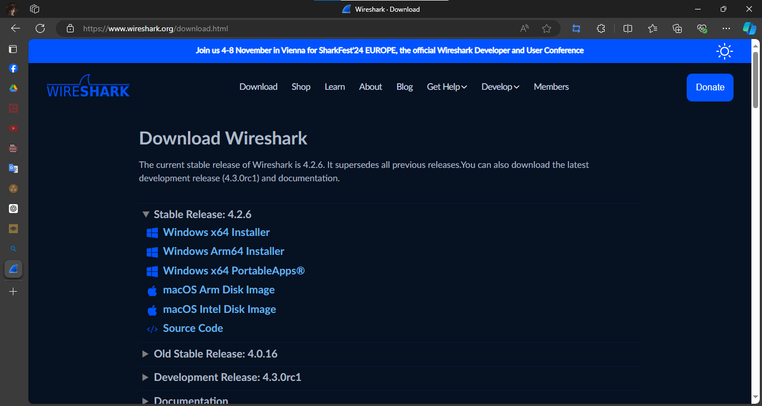

After downloading, execute the file and accept the installation requirements.

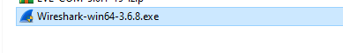

After installing the wireshark interface appears. Ready to catch packets via the network interface.

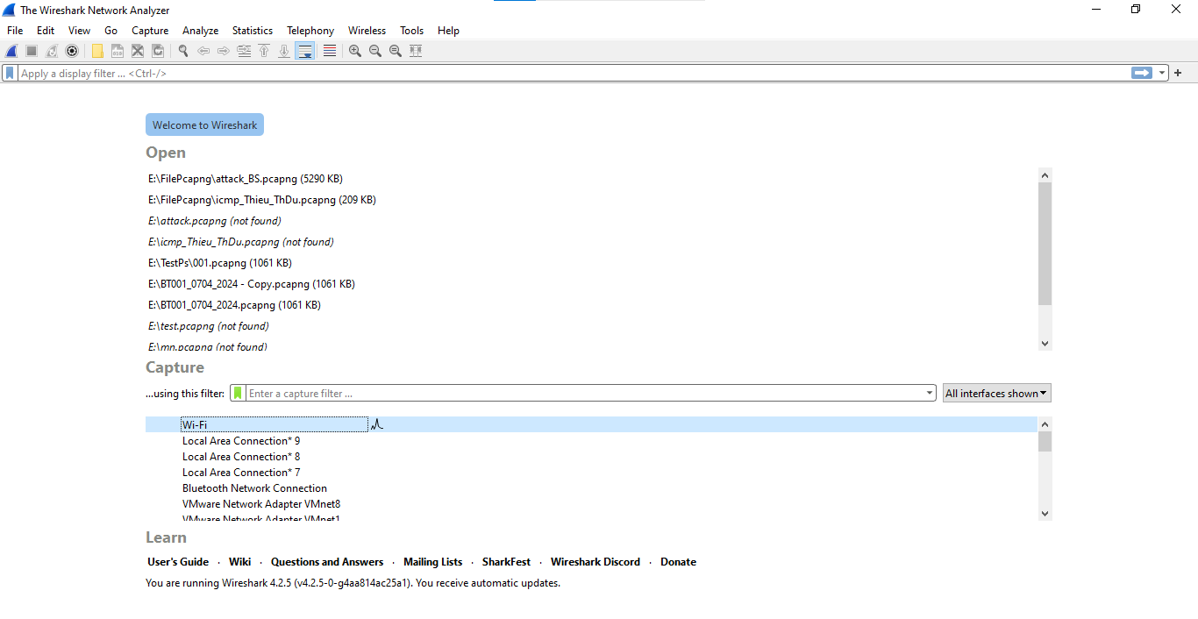

**Operation of use:**

**Capture**: Select the network interface card (e.g. wifi)

Press the blue button in the left corner to get started.

Press Stop to stop.

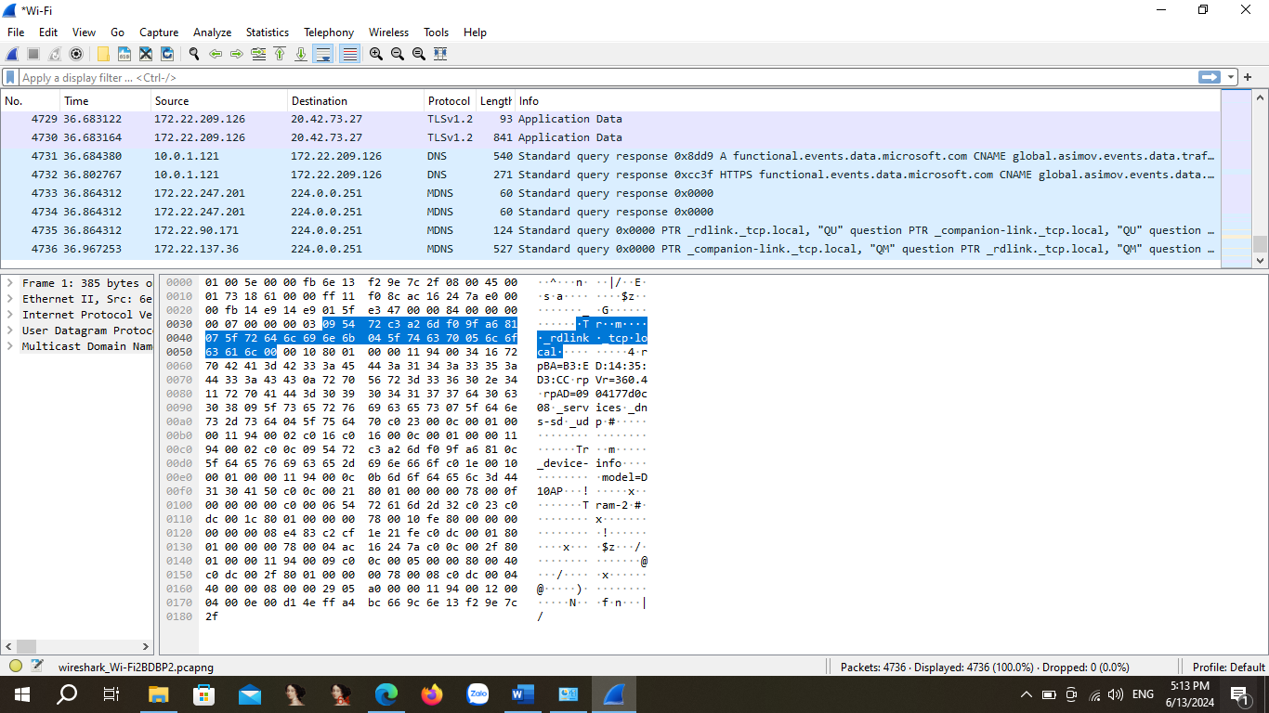

Adjust the layout: edit -> preferences -> appearance -> Layout

New Capture: 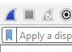 Select the blue button -> Continue without Saving.



open capture file, save capture file, close this capture file, reload this file, find a packet, ”<- ->” Scroll Backward, Forward Packages Next

Go to packet: packet <No.>

Arrows: up, down indicates the first and last packet.

Auto matically scroll to the last packet during a live capture: Automatically scroll to the last package during live shooting.

Draw packets using your coloring rules: Draw the packs using your coloring rules. – Add an easy-to-see color – Simply understand.

Fonts: zoom in, zoom out, return to default, align columns to default.

**Capture options:** choose card mạng, scan , stop

**Capture options: **

Promiscuous Mode:

- off: Packet is only for my device

- on: Allows packet retrieval within the network

**Filters:** perform fast packet filtering

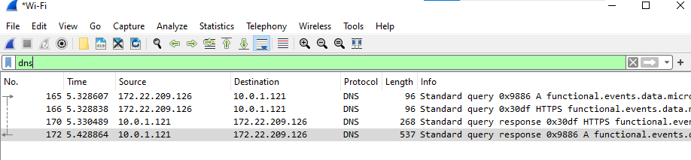

http.request.method == “post”

**Capture Filters:**

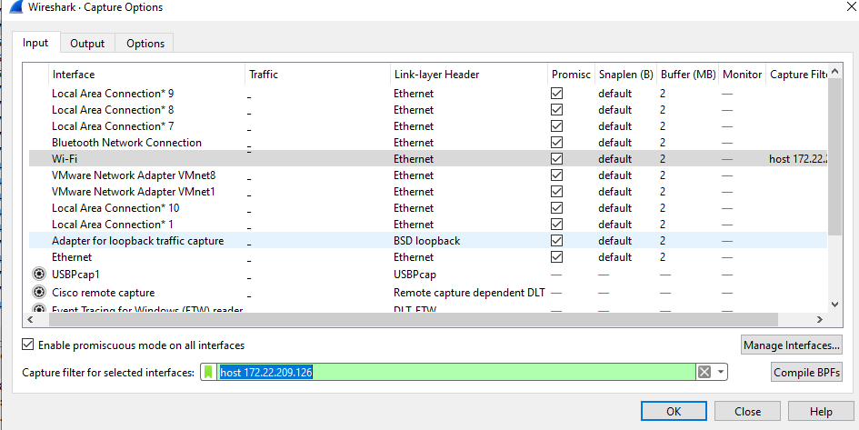

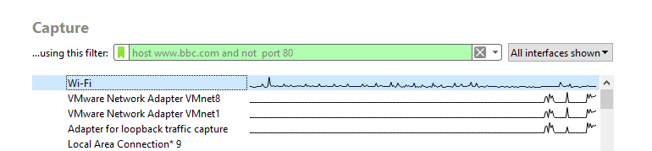

Catch packets from 1 specific host.

1 Count selected others:

port 443

dst 172.22.209.126 and port 443// Filtering with destination addresses and network ports

src 172.10.22.12 // filter with source// use and to combine commands

host [www.bbc.com](http://www.bbc.com) and not port 80

2.4 Install Firewall Pfsense

Time Server Configuration

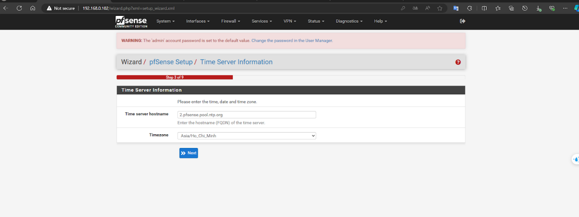

WAN Configuration

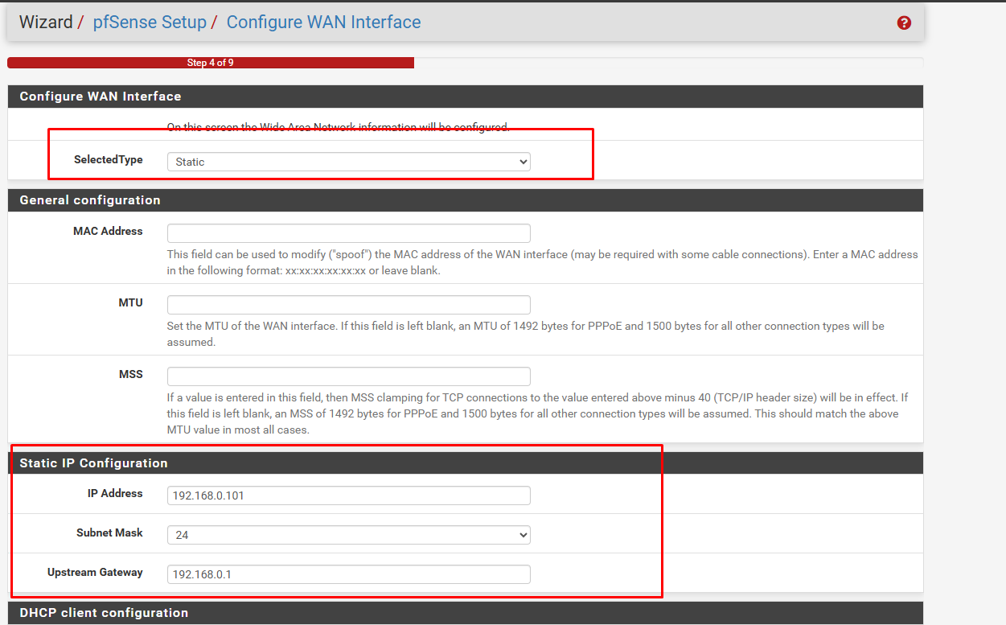

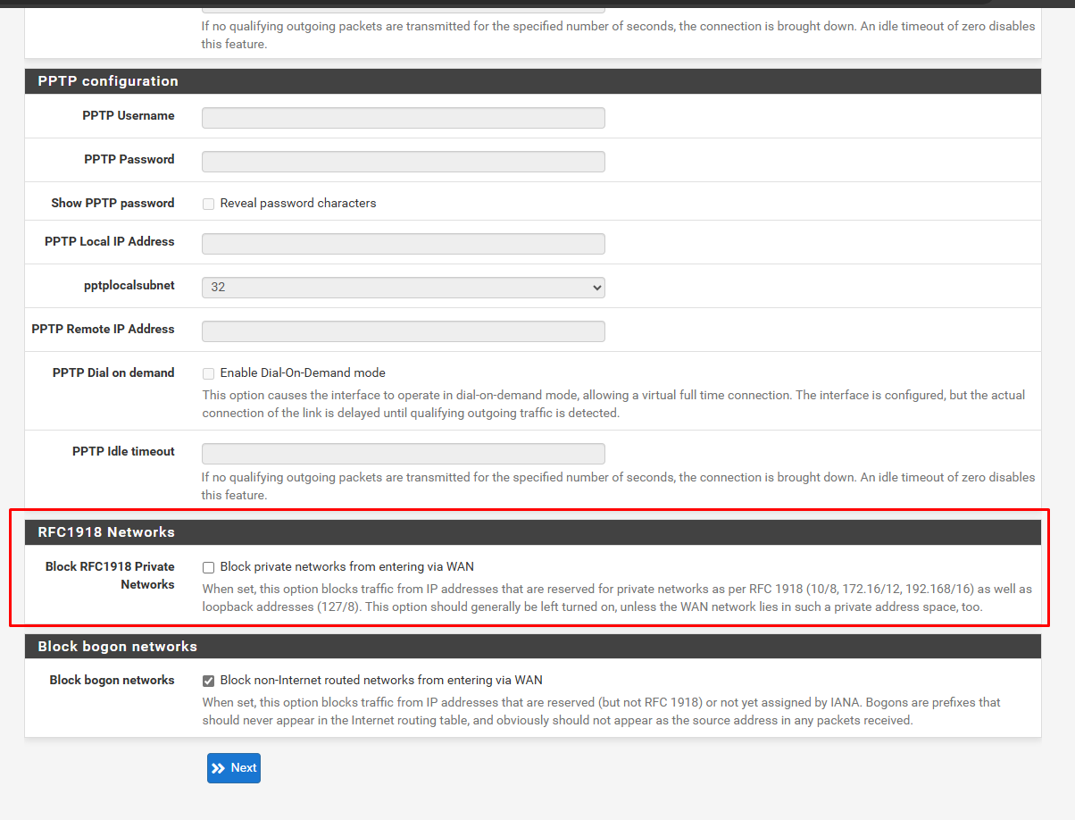

LAN interface configuration

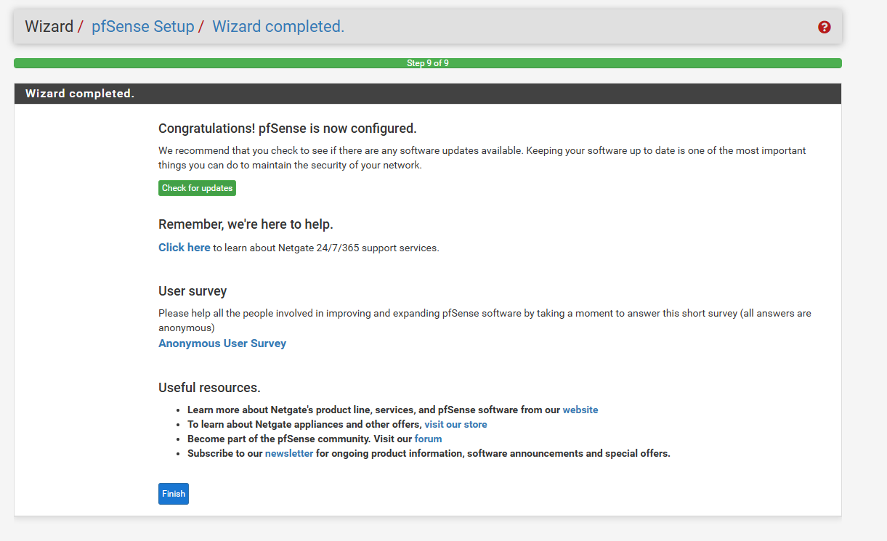

To facilitate the configuration of pfSense when accessing from a computer in the home network (located on pfSense's WAN), I will create a new Firewall Rule that allows access to the Web UI from the WAN.

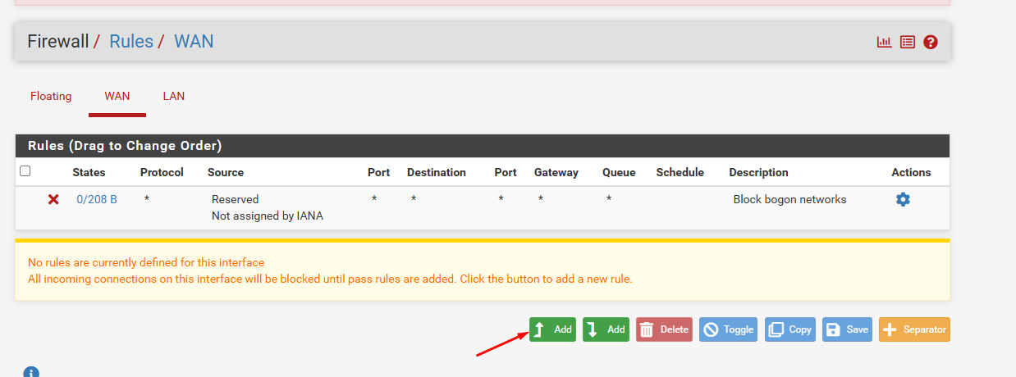

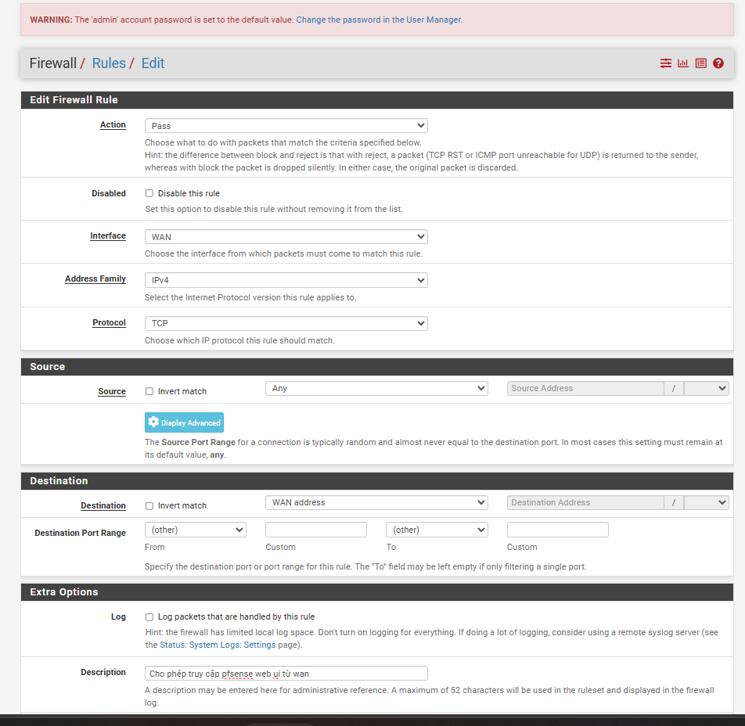

install suricata

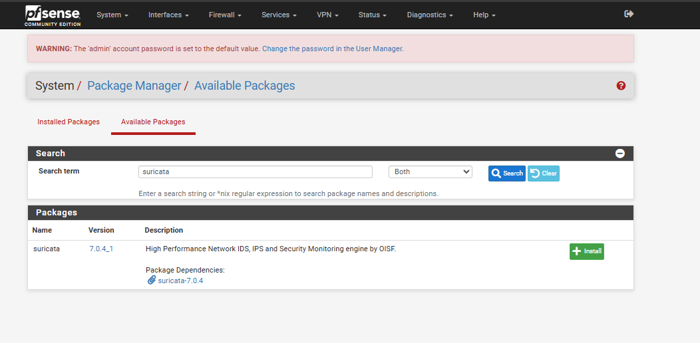

Setting rules for suricata

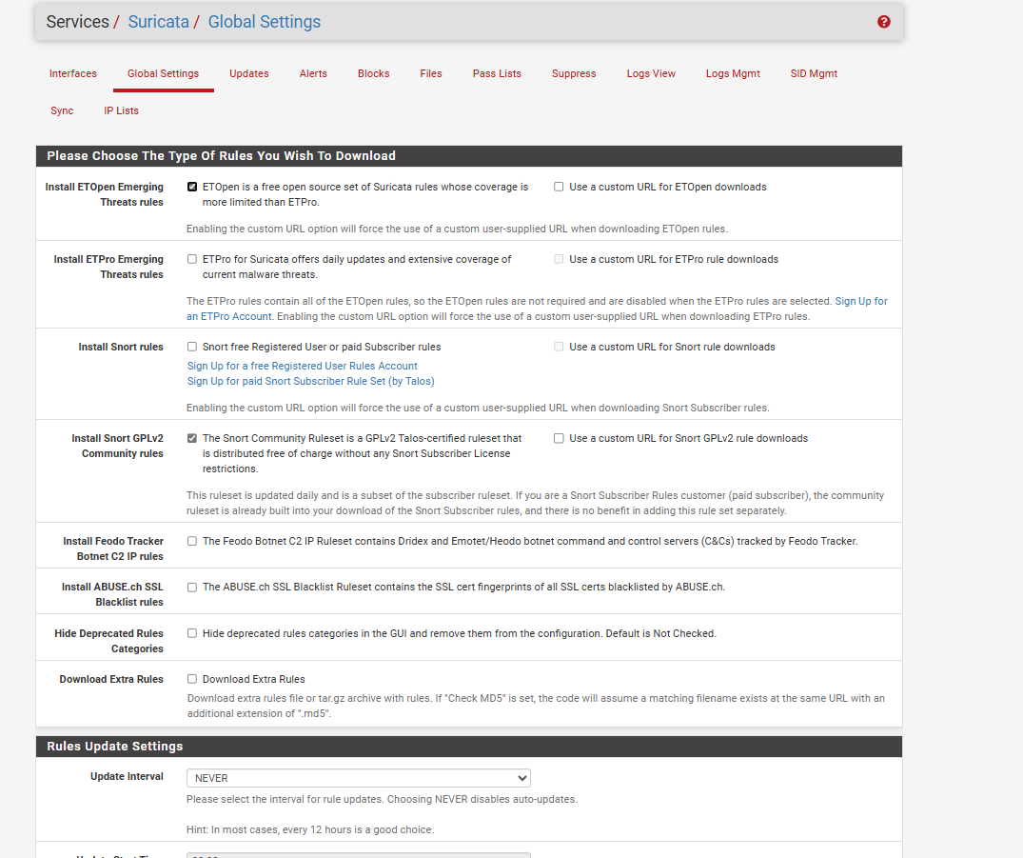

Then select Update

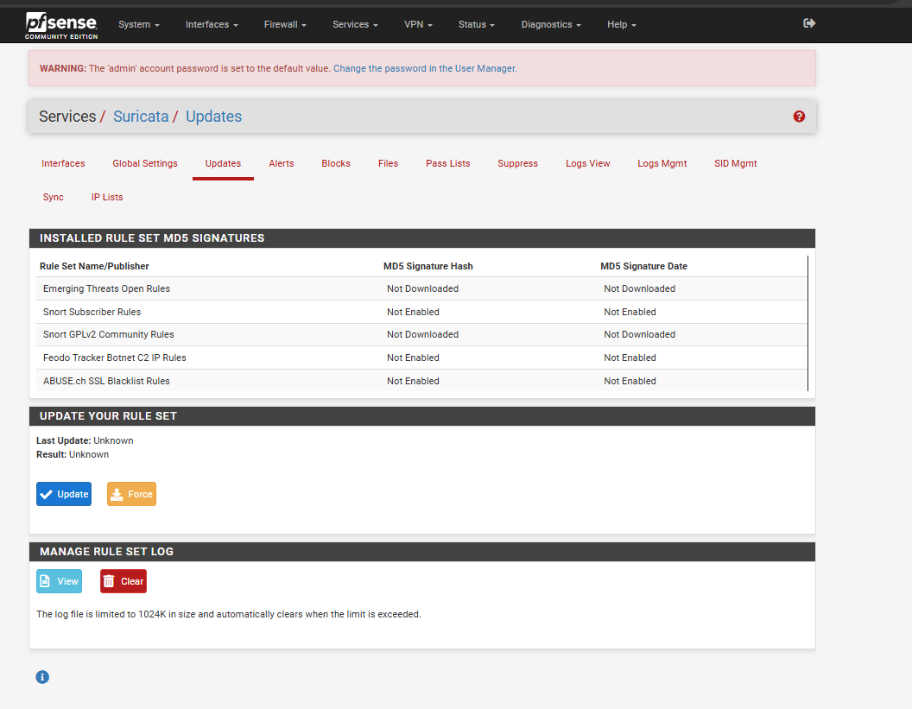

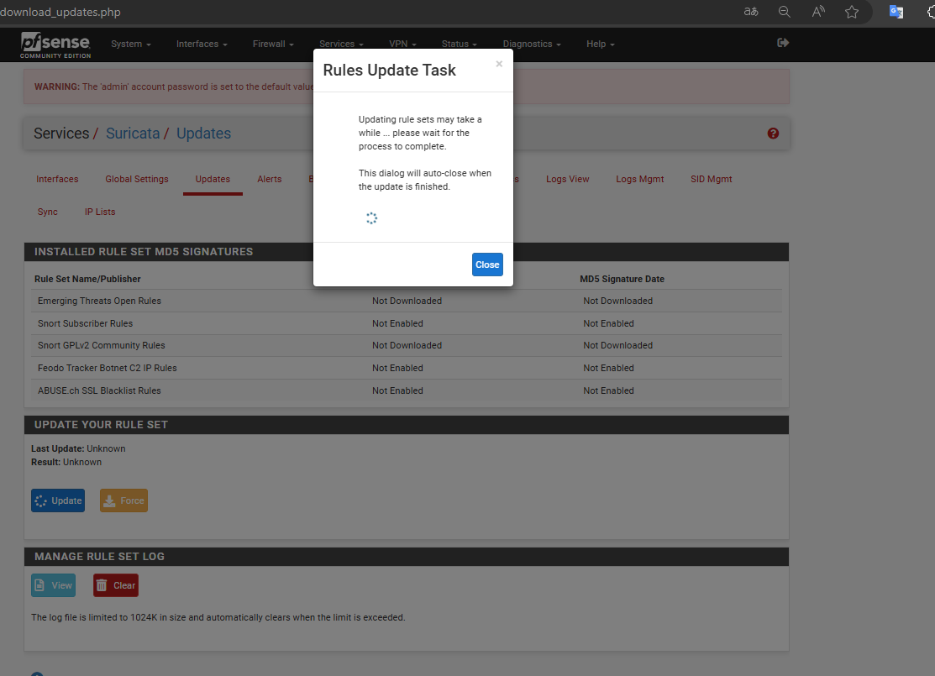

Configure the following additional rules

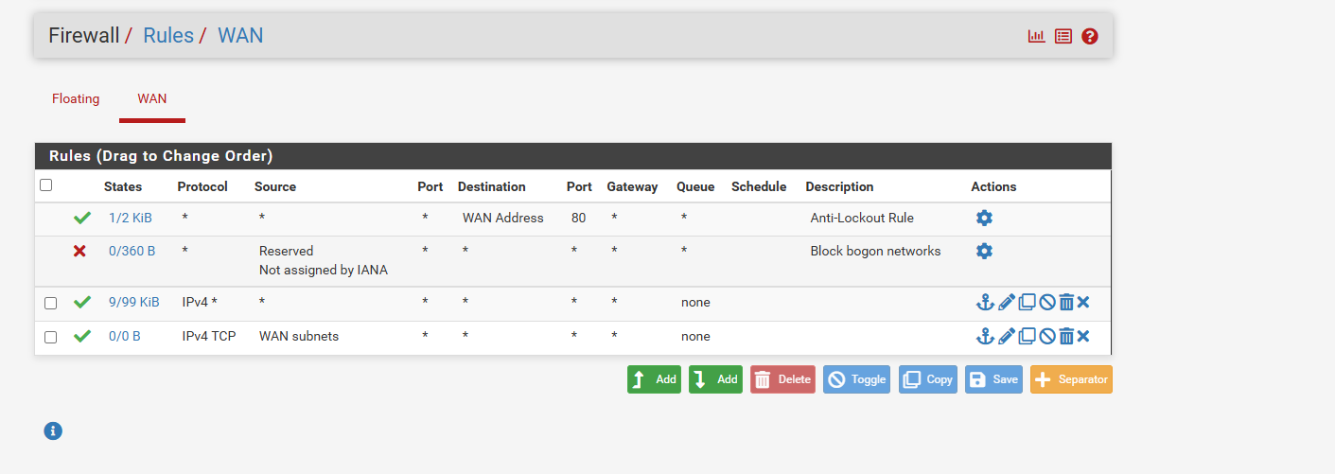

rules of suricata

alert http any any -> any any (msg: "Possible SQL Injection attack (Contains singlequote)"; flow:established,to_server; content:"'"; nocase; http_uri; sid:50300001;)

alert http any any -> any any (msg: "Possible SQL Injection attack (Contains UNION)"; flow:established,to_server; content:"union"; nocase; http_uri; sid:50300002;)

alert http any any -> any any (msg: "Possible SQL Injection attack (Contains SELECT)"; flow:established,to_server; content:"select"; nocase; http_uri; sid:50300003;)

alert http any any -> any any (msg: "Possible SQL Injection attack (Contains singlequote POST DATA)"; flow:established,to_server; content:"'"; nocase; http_client_body; sid:50300004;)

alert http any any -> any any (msg: "Possible SQL Injection attack (Contains UNION POST DATA)"; flow:established,to_server; content:"union"; nocase; http_client_body; sid:50300005;)

alert http any any -> any any (msg: "Possible SQL Injection attack (Contains SELECT POST DATA)"; flow:established,to_server; content:"select"; nocase; http_client_body; sid:50300006;)

alert http any any -> any any (msg:"Possible XSS attack, script tag"; content:"script"; nocase; pcre:"/(<|%3C|%253C)script/smi"; classtype:web-application-attack; sid:50100001; rev:1;)

#alert http any any -> any any (msg:"Possible XSS attack, js event handler"; content:"on"; nocase; pcre:"/on\w+(%3D|=)/smi"; classtype:web-application-attack; sid:50100002; rev:1;)

alert http any any -> any any (msg:"Possible XSS attack, js protocol"; content:"javascript"; nocase; pcre:"/javascript(:|%3A)/smi"; classtype:web-application-attack; sid:50100003; rev:1;)

alert http any any -> any any (msg:"SSRF attack, internal IP access"; content:"http"; nocase; pcre:"/http:\/\/localhost/smi"; classtype:web-application-attack; sid:50100004; rev:2;)

alert http any any -> any any (msg:"Possible SSRF attack, metadata service access"; content:"http"; nocase; pcre:"/http:\/\/127\.0\.0\.1/smi"; classtype:web-application-attack; sid:50100005; rev:1;)

alert tcp any any -> any any (msg:"Possible DDoS attack, SYN flood"; flags:S; threshold:type both, track by_src, count 20, seconds 10; classtype:attempted-dos; sid:50100006; rev:1;)

alert http any any -> any any (msg:"Possible DDoS attack, high request rate"; content:"GET"; nocase; threshold:type both, track by_src, count 100, seconds 10; classtype:attempted-dos; sid:50100007; rev:1;)

alert tcp any any -> any [21,22,23,25,53,80,88,110,135,137,138,139,143,161,389,443,445,465,514,587,636,853,993,995,1194,1433,1720,3306,3389,8080,8443,11211,27017,51820] (msg:"POSSBL PORT SCAN (NMAP -sS)"; flow:to_server,stateless; flags:S; window:1024; tcp.mss:1460; threshold:type threshold, track by_src, count 20, seconds 70; classtype:attempted-recon; sid:3400001; priority:2; rev:1;)

alert tcp any any -> any ![21,22,23,25,53,80,88,110,135,137,138,139,143,161,389,443,445,465,514,587,636,853,993,995,1194,1433,1720,3306,3389,8080,8443,11211,27017,51820] (msg:"POSSBL PORT SCAN (NMAP -sS)"; flow:to_server,stateless; flags:S; window:1024; tcp.mss:1460; threshold:type threshold, track by_src, count 7, seconds 135; classtype:attempted-recon; sid:3400002; priority:2; rev:2;)

alert tcp any ![22,25,53,80,88,143,443,445,465,587,853,993,1194,8080,51820] -> any ![22,25,53,80,88,143,443,445,465,587,853,993,1194,8080,51820] (msg:"POSSBL PORT SCAN (NMAP -sT)"; flow:to_server; window:32120; flags:S; threshold:type threshold, track by_src, count 20, seconds 70; classtype:attempted-recon; sid:3400003; rev:3;)

alert tcp any ![22,25,53,80,88,143,443,445,465,587,853,993,1194,8080,51820] -> any ![22,25,53,80,88,143,443,445,465,587,853,993,1194,8080,51820] (msg:"POSSBL PORT SCAN (NMAP -sA)"; flags:A; flow:stateless; window:1024; threshold:type threshold, track by_dst, count 20, seconds 70; classtype:attempted-recon; sid:3400004; priority:2; rev:5;)

alert tcp any any -> any any (msg:"POSSBL PORT SCAN (NMAP -sX)"; flags:FPU; flow:to_server,stateless; threshold:type threshold, track by_src, count 3, seconds 120; classtype:attempted-recon; sid:3400005; rev:2;)

alert ip any any -> any any (msg:"POSSBL SCAN FRAG (NMAP -f)"; fragbits:M+D; threshold:type limit, track by_src, count 3, seconds 1210; classtype:attempted-recon; sid:3400006; priority:2; rev:6;)

alert udp any any -> any [53,67,68,69,123,161,162,389,520,1026,1027,1028,1029,1194,1434,1900,11211,12345,27017,51820] (msg:"POSSBL PORT SCAN (NMAP -sU)"; flow:to_server,stateless; classtype:attempted-recon; sid:3400007; priority:2; rev:6; threshold:type threshold, track by_src, count 20, seconds 70; dsize:0;)

alert udp any any -> any ![53,67,68,69,123,161,162,389,520,1026,1027,1028,1029,1194,1434,1900,11211,12345,27017,51820] (msg:"POSSBL PORT SCAN (NMAP -sU)"; flow:to_server,stateless; classtype:attempted-recon; sid:3400008; priority:2; rev:6; threshold:type threshold, track by_src, count 7, seconds 135; dsize:0;)

alert tcp any ![21,22,23,25,53,80,88,110,135,137,138,139,143,161,389,443,445,465,514,587,636,853,993,995,1194,1433,1720,3306,3389,8080,8443,11211,27017,51820] -> any 4444 (msg:"POSSBL SCAN SHELL M-SPLOIT TCP"; classtype:trojan-activity; sid:3400020; priority:1; rev:2;)

alert udp any ![53,67,68,69,123,161,162,389,520,1026,1027,1028,1029,1194,1434,1900,11211,12345,27017,51820] -> any 4444 (msg:"POSSBL SCAN SHELL M-SPLOIT UDP"; classtype:trojan-activity; sid:3400021; priority:1; rev:2;)

To forward the log from pfsense via Siem we do the following

Status -> Systems log -> settings

Select syslog

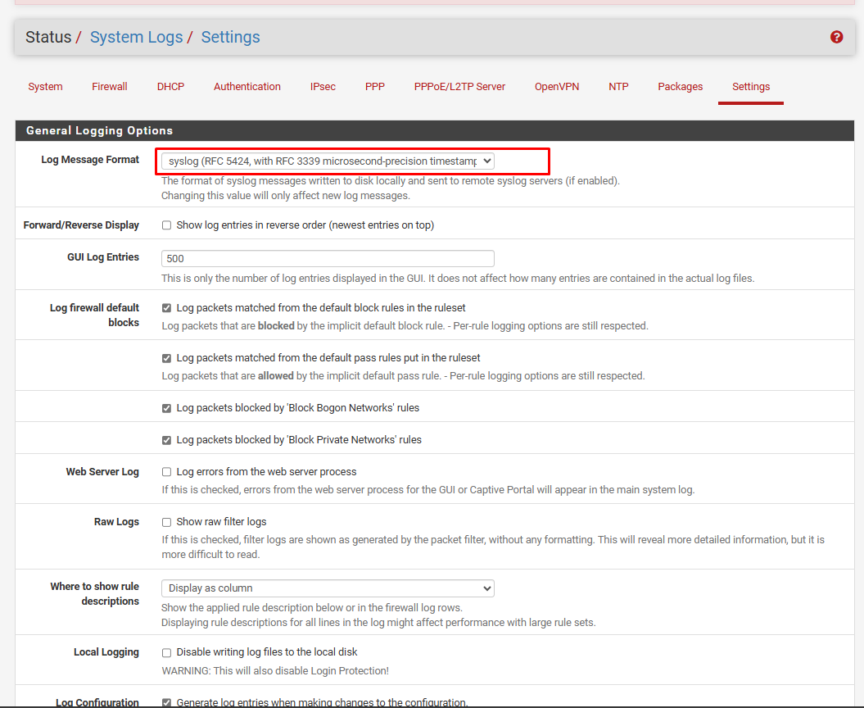

Tick Enable remote loggin, then enter the siem's ip and port to forward through

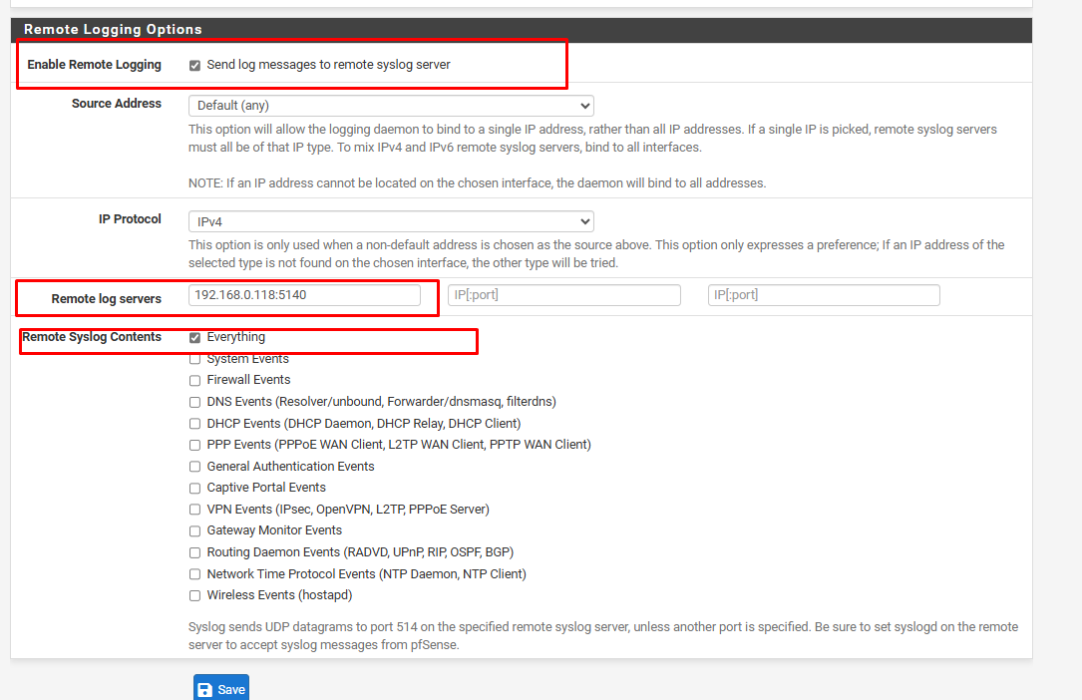

Then through the rules of the WAN added as follows

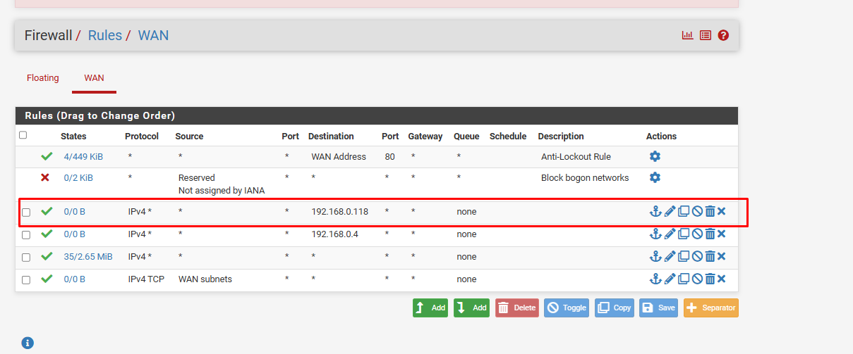

Below is a demonstration of PFSENSE receiving an alert when the web (192.168.0.69) is attacked by an attacker (192.168.0.106)

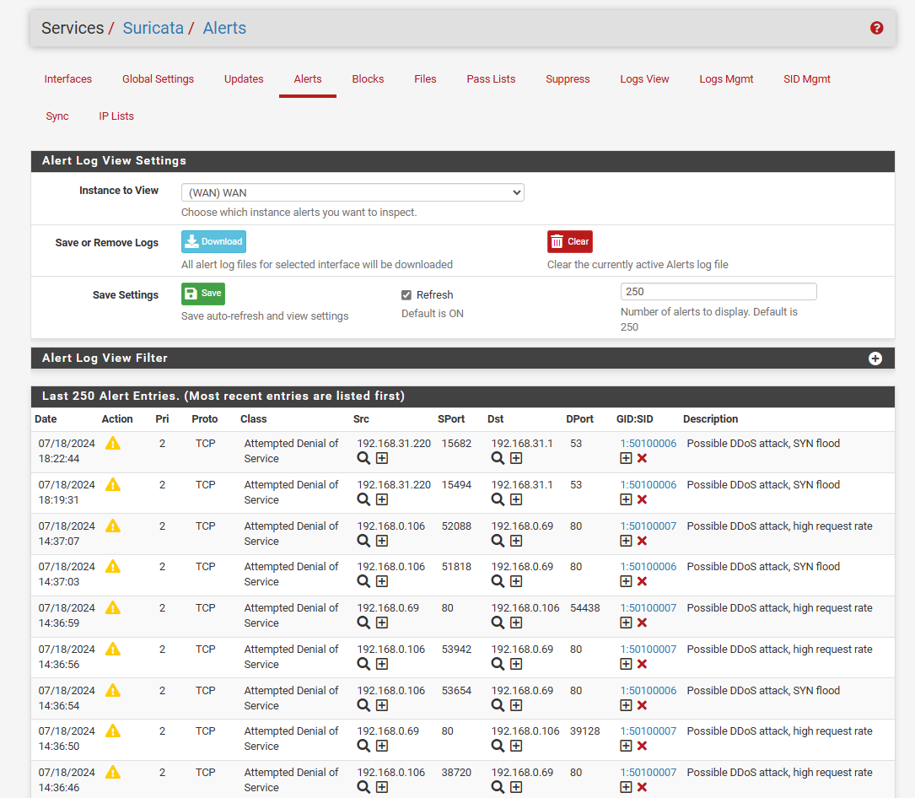

2.5 Install SIEM

2.5.1 install ELK

**ELK** is to explore how to integrate Elasticsearch, logstash, and Kibana to start creating a security information and event management (SIEM) tool on Ubuntu server. SIEM tools are used to collect, aggregate, store, and analyze event data to search for security threats and suspicious activity on our networks and servers.

Components that will be used to build the SIEM tool:

- Elasticsearch: to store, index and search security events coming from Suricata servers.

- Logstash: collects, processes, and forwards logs and events from various sources to destinations such as Elasticsearch.

- Kibana: to display security event logs stored in Elasticsearch.

**Install the public GPG signing key:**

curl -fsSL https://artifacts.elastic.co/GPG-KEY-elasticsearch | sudo gpg --dearmor -o /etc/apt/keyrings/elasticsearch.gpg

**Add Elasticsearch repository**:

Echo "deb [signed-by=/etc/apt/keyrings/elasticsearch.gpg] https://artifacts.elastic.co/packages/8.x/apt stable main" | sudo tee /etc/apt/sources.list.d/elastic-8.x.list

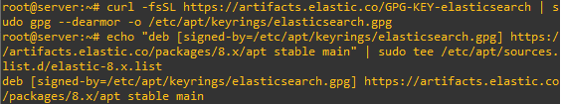

2.5.2 Install ElasticSearch

apt update

apt install elasticsearch

Configure the Elasticsearch network

Open the file /etc/elasticsearch/elasticsearch.yml

add a new line after the network.host: 192.168.0.1 line to configure network.bind_host as below:

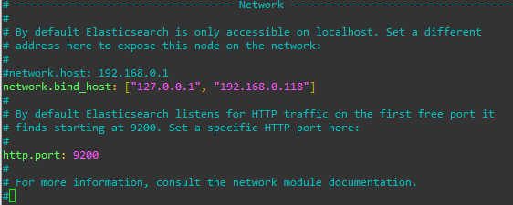

**Configure Elasticsearch password:**

Create a password for the Elasticsearch user as follows:

cd /usr/share/elasticsearch/bin

./elasticsearch-setup-passwords auto

got the following output.

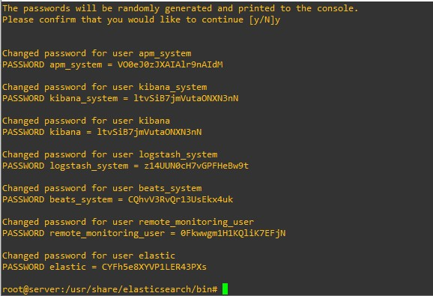

**Configure Elasticsearch to auto-start during system startup:**

systemctl enable elasticsearch.service



Start up and check the system status

systemctl start elasticsearch.service

systemctl status elasticsearch.service

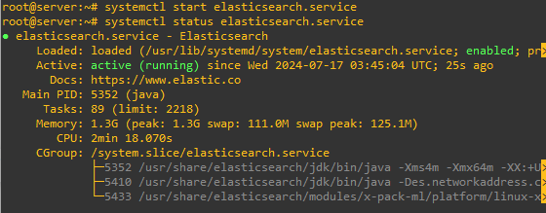

2.5.3 Install Kibana

**Install:**

apt install kibana

**Enable in Kibana xpack.security:**

generate the necessary encryption keys using kibana-encryption-keys found in the /usr/share/kibana/bin directory as follows:

cd /usr/share/kibana/bin/

./kibana-encryption-keys generate -q

**The following results:**

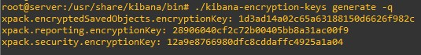

**Add the above results to Kibana's configuration file**

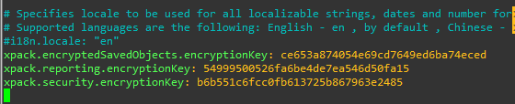

**Configure Kibana network**

To configure Kibana's network so that it is available on the Elasticsearch server's IP address, add a new line after the line with the server's IP address ( #server.host: "localhost" ) in the file /etc/kibana/kibana .yml:

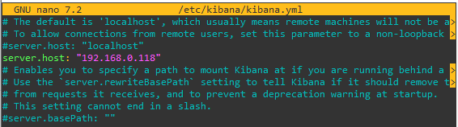

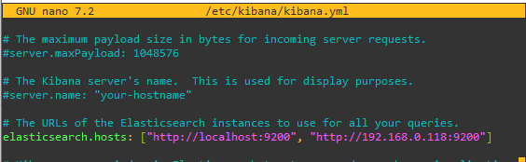

check Start up and check the system status

systemctl start kibana

systemctl status kibana

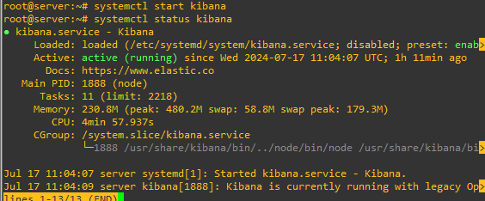

2.5.4. Install Logstash

Add the Logstash repo

echo "deb [signed-by=/etc/apt/keyrings/elasticsearch.gpg] https://artifacts.elastic.co/packages/8.x/apt stable main" | sudo tee -a /etc/apt/sources.list.d/logstash-8.x.list

Install kibana

apt update

apt install logstash

Configure Logstash

Logstash configuration files are JSON-Format files located in the /etc/logstash/conf.d/ directory. A Logstash server configuration consists of three sections; **input**, **filter** and **output**

Create an input configuration:

nano /etc/logstash/conf.d/01-inputs.conf

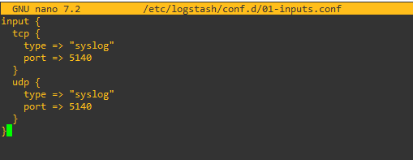

**Create an syslog configuration:**

Nano /etc/logstash/conf.d/10-syslog.conf

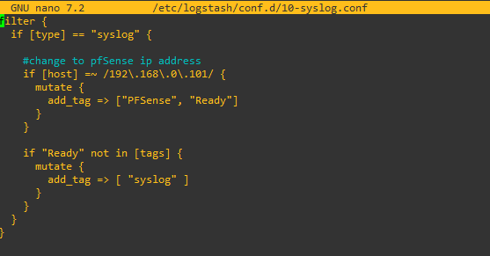

Create an outputs configuration:

nano /etc/logstash/conf.d/30-outputs.conf

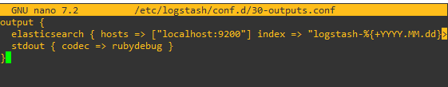

**Start up and check the system status**

systemctl start logstach.service

systemctl status kibana logstach.service

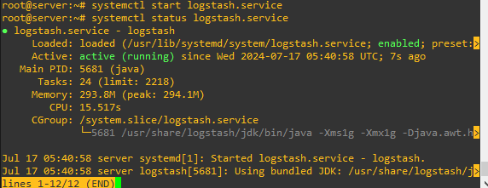

**Connect to Kibana using SSH**

Run the following command in a terminal to create an SSH tunnel to Kibana:

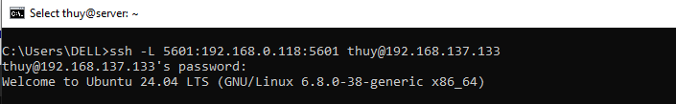

In there:

-L forwards traffic to our local system on port 5601 to the remote server.

Section 192.168.0.118:5601 specifies the service on the Elasticsearch server where traffic will be forwarded to.

IP 192.168.137.133 is the public IP address they use to connect and manage the server.

-N instructs SSH not to run a command like a /bin/bash process, and instead, just keep the connection open.

Log in to the Kibana server using the Elastic Username and password created earlier

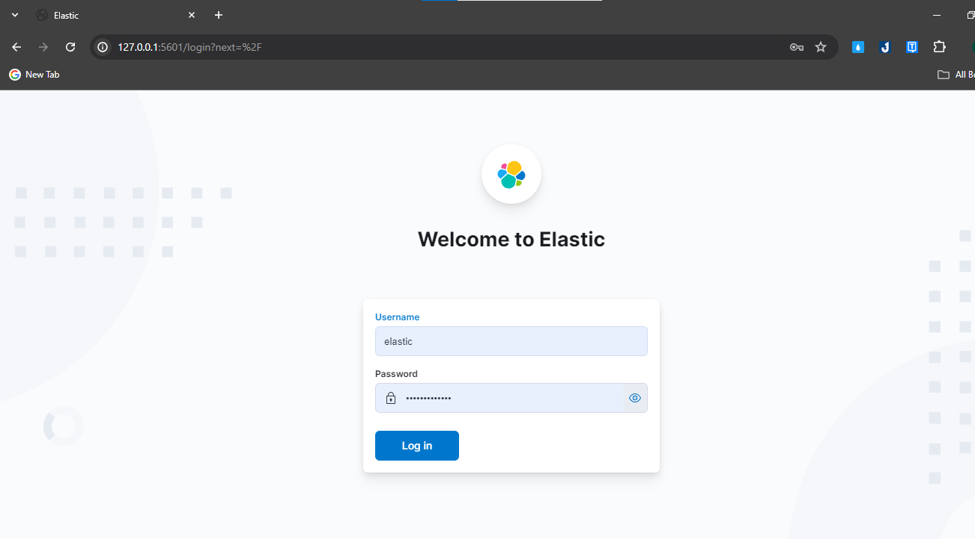

Interface after logging in

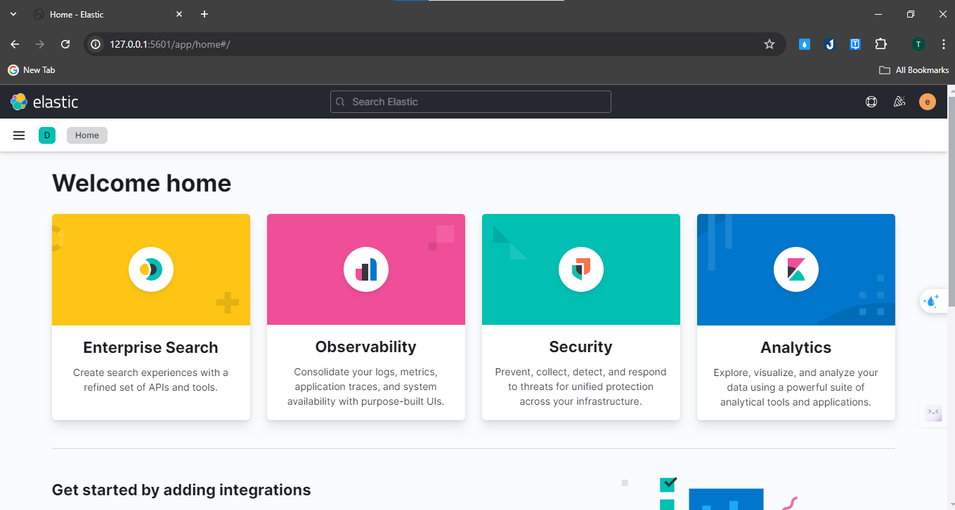

Go to discover to see the log

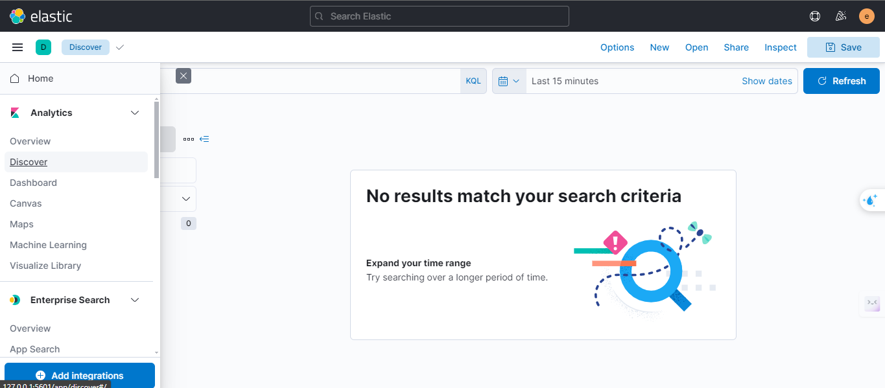

want to add devices to "Manager index pattern fields"

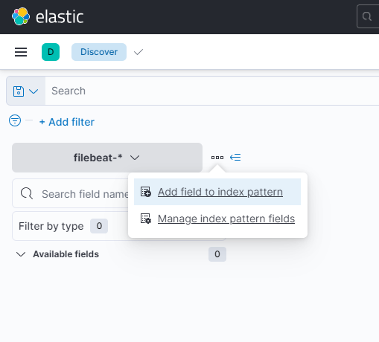

See devices in index management

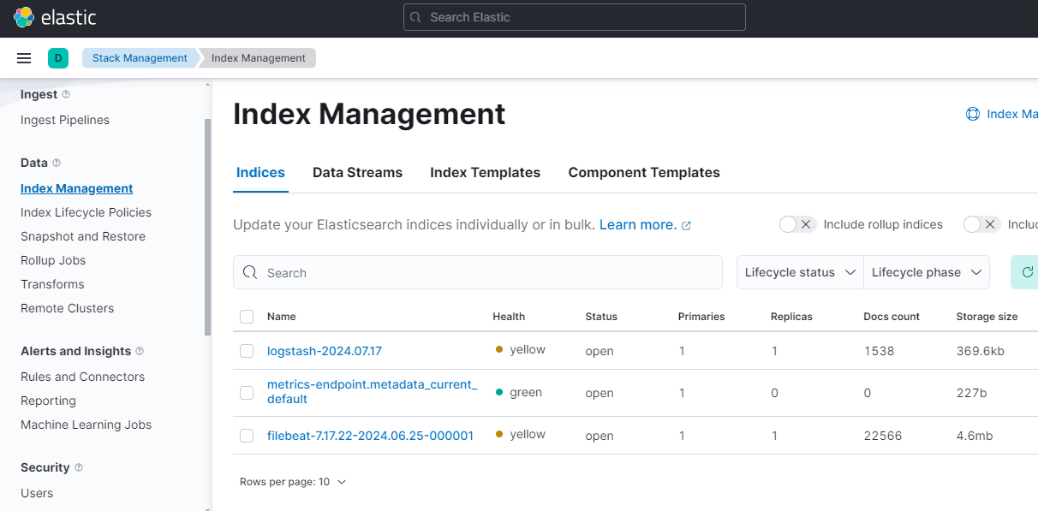

Go to "index patterns" to create index patterns

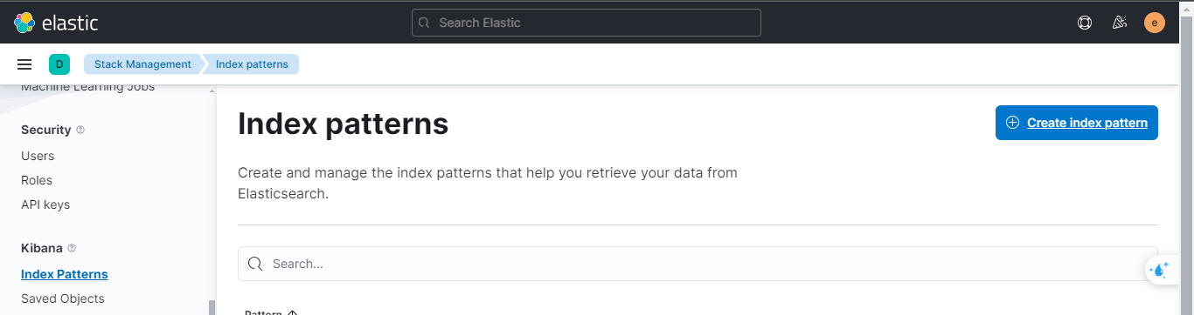

Select the corresponding index patterns on the right

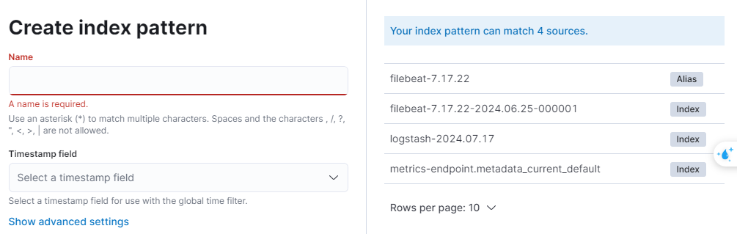

Go back to discover, select log type and view log

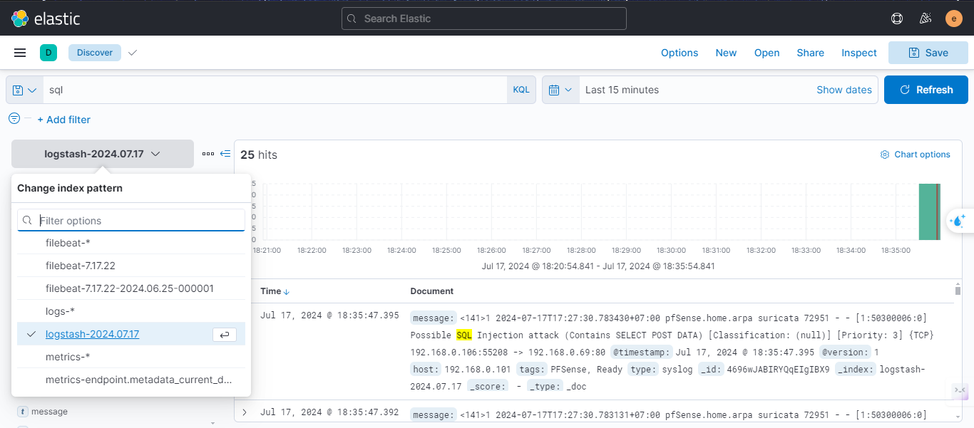

2.6 Install WebServer

Tải window Server: <https://www.microsoft.com/en-us/evalcenter/evaluate-windows-server-2016/>

Boot the operating system using the ISO file. Fill in the parameters and press next until the installation is complete.

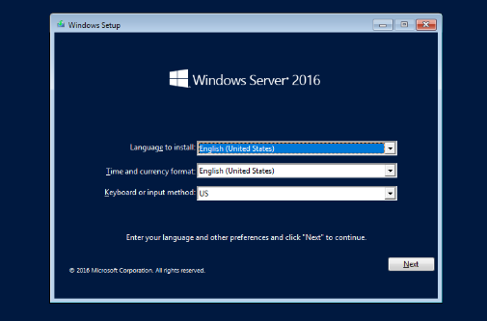

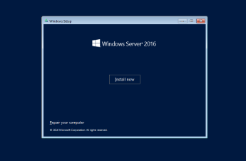

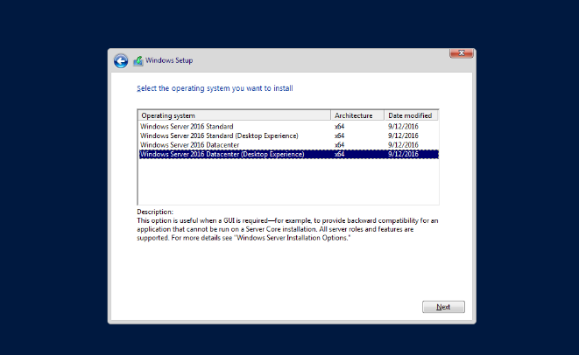

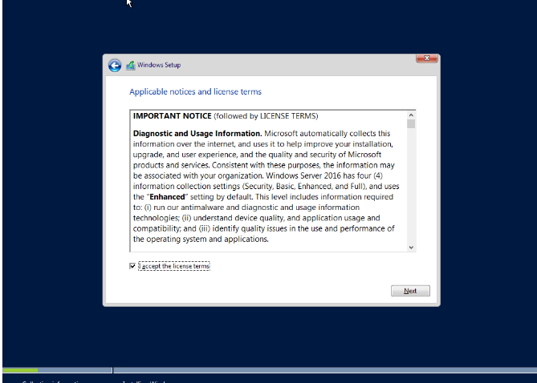

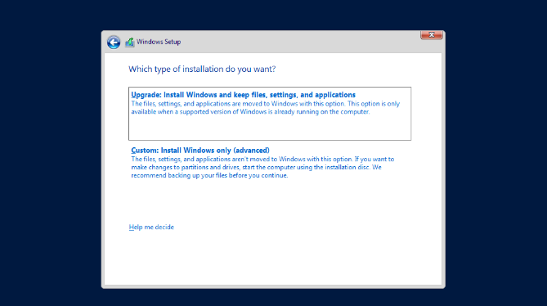

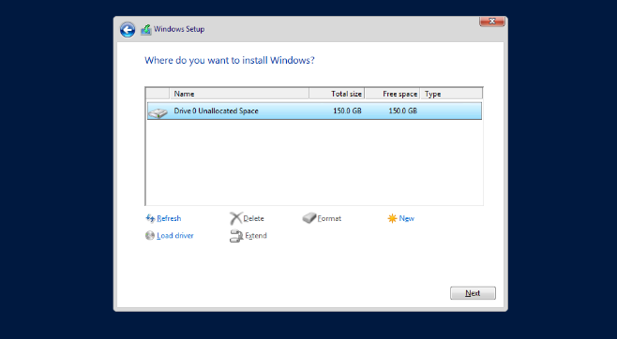

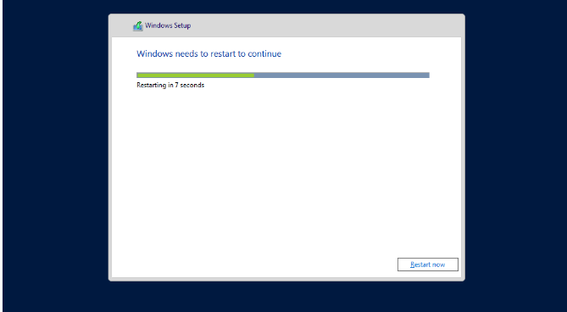

Installation is complete.



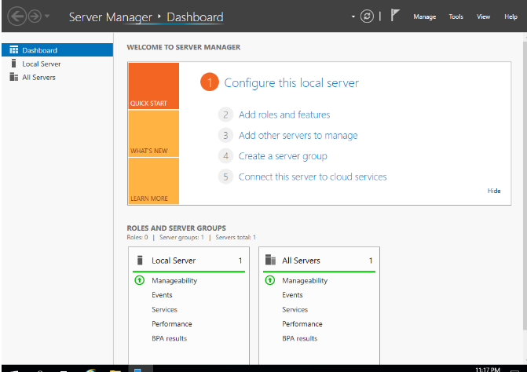

Go to Server manager and install IIS Roles.

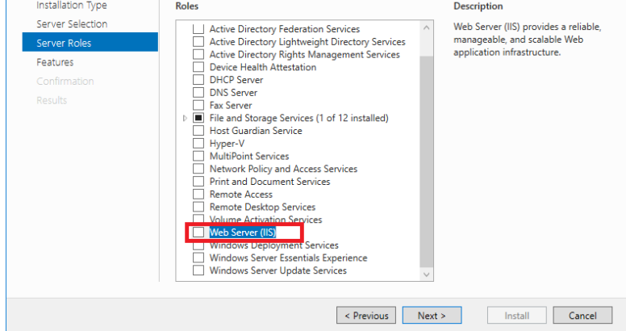

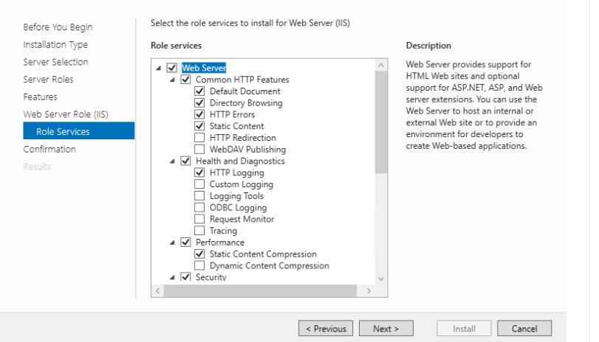

After installing IIS, to administer the service, go to Server Manager and select Tools and select Internet Information Services (IIS) Manager.

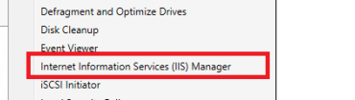

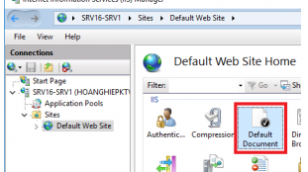

Create an index/html file and access it, go to web01.com.

PART3: ATTACK SCENARIO AND DEMO

**Prepare the tools**

- Nmap: A gateway scanning tool.

- SQLmap: A tool that automates SQL Injection attacks.

Target: Vulnerable websites with SQL Injection, SSRF, and XSS vulnerabilities.

**Scanning Ports with Nmap**

Before the attack, it is necessary to scan the ports to find out what services are running on the target machine.

**Nmap Command:**

nmap -sV -sC -Pn web01.com



The result is that the ports 21, 80 (http web server), and some other ports are active

**SQL Injection Attacks with SQLmap**

Check your website's login form with SQL injection

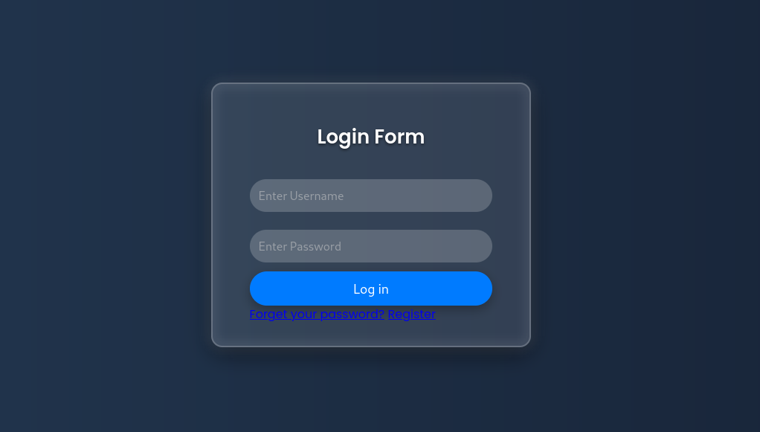

**SQLmap command:**

sqlmap -u http://192.168.1.207/connect.php --data="uname=*&psw=abc" --dbs --batch

After the attack is successful, the databases in the server are obtained:

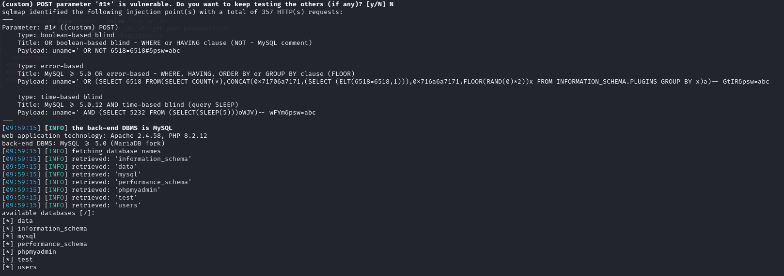

**Attack SSRF (Server-Side Request Forgery)**

SSRF Vulnerability Detection and Exploitation:

Assuming your site has a function that allows you to enter a URL, you can try entering an internal URL:

http://localhost/connect.php

The result of the successful exploitation is the src code of the server's internal url:

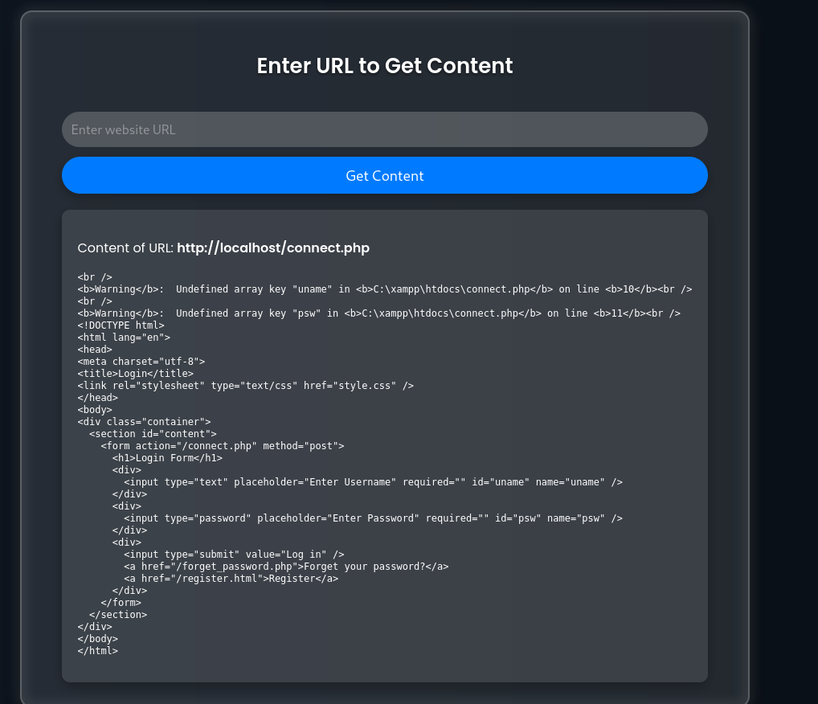

**XSS (Cross-Site Scripting) Attacks**

XSS vulnerability detection and exploitation:

You can try to insert XSS code:

<script>alert('XSS');</script>

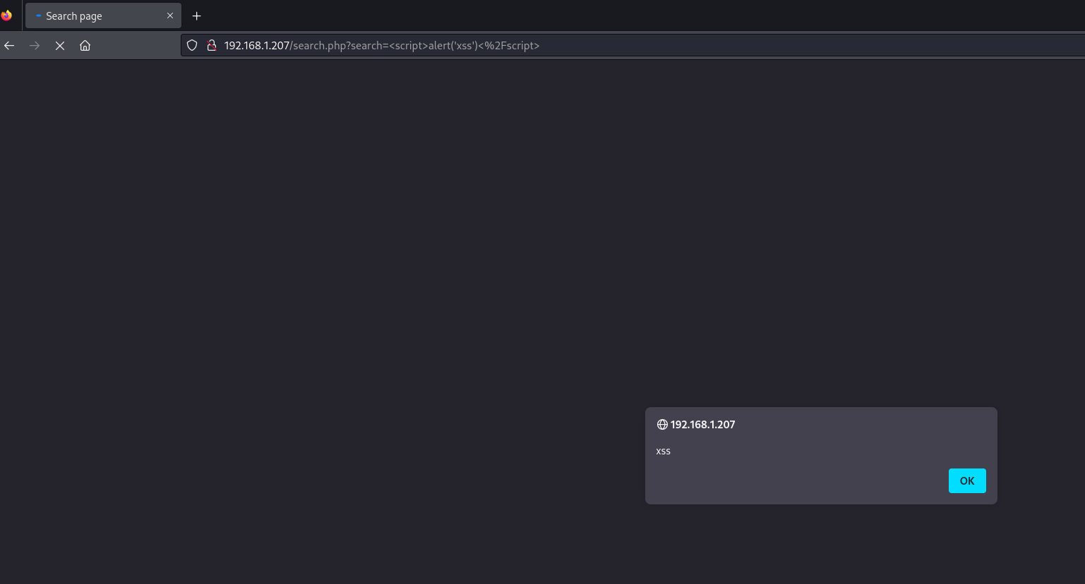

PART4: ANALYZE AND IDENTIFY VULNERABILITIES

4.1 Analysis static wireshark

4.1.1 ICPM packet analysis

**Purpose:** Check the network, diagnose and handle connection problems.

**Analyze:**

Use wireshark to capture packets or open the captured "pcapng" file for analysis.

Open the file "pcapng" to perform packet analysis: "Windows + R" type "cmd" and press enter.

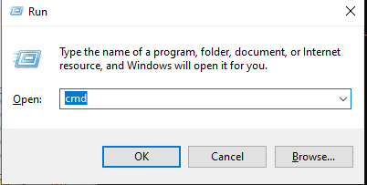

Enter the file path to open + Enter. Then the wireshark interface appears.

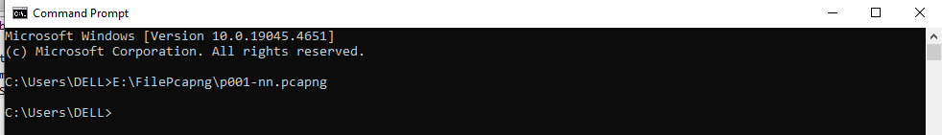

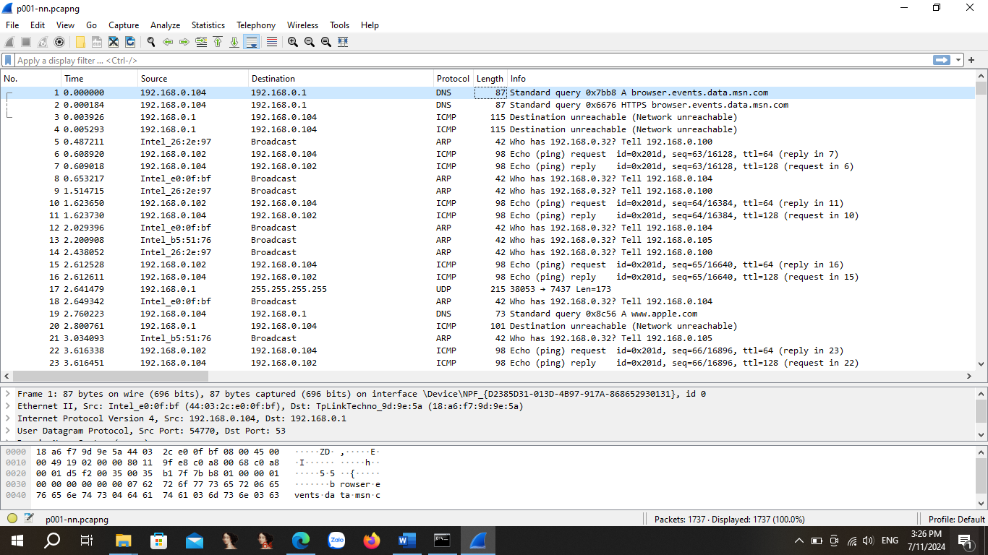

Type "Apply a display filter icmp" to filter out icmp packets.

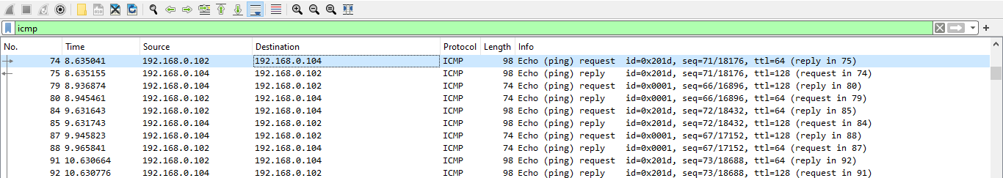

Looking at packet No.74, we can see information such as:

Packet gain time: 8.635041. Source sends packets to 192.168.0.102. Destination address: 192.168.0.104. Protocol: ICMP. Duration: 74 bytes

Packet No.74 is an Echo request of the ping command: request to test and connect to 1 device or server.

ID: ‘0x201d’: Use pairing of Echo Request and Echo Reply packets respectively. Sequence number: '71/18176' the ICMP packet sequence number in the outgoing packet string.

Ttl: time-to-live Anti-Routing Loop Mechanism: Every time passing through the router ttl drops 1. The router receives the ttl=0 packet, the packet is canceled.

Package No.74 shows that if you want to see its reply package, you can see package No.75 (reply in 75). Package No.75 wants to see its request, see Package No.74.

Thereby, it shows that after finishing a request-reply process, cmd returns a reply command on the cmd interface

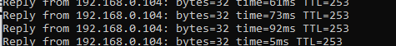

**Detailed Analysis:**

Frame package overview:

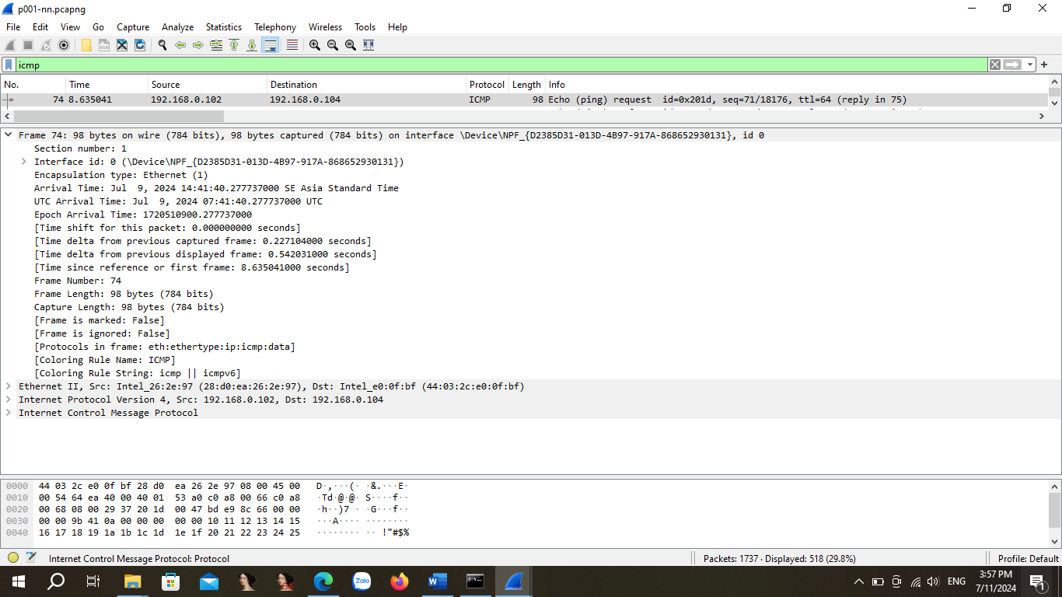

Use Ethernet for layer2: Indicates source and destination MAC address information.

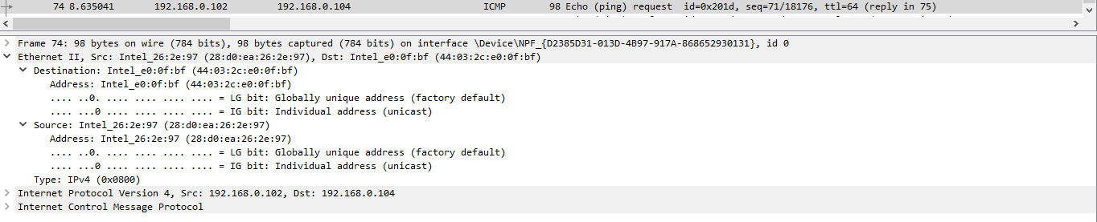

Packet analysis at layer3: indicates the version4 ip information. Indicates the source address and destination address. The protocol uses ICMP. Total lengther: 84.

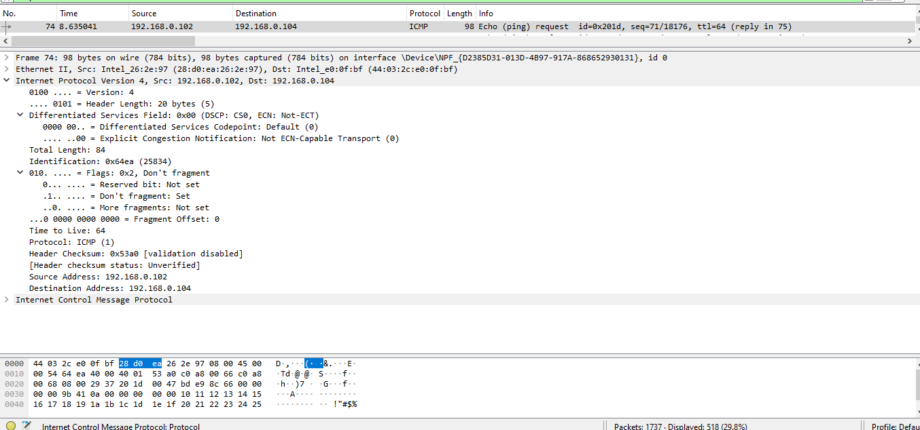

Layer 4 packet analysis: Analysis of this paragraph shows that the ICMP protocol is being used. Type 8, code 0 indicates that the request package is being used. Checksum checks integrity correct.

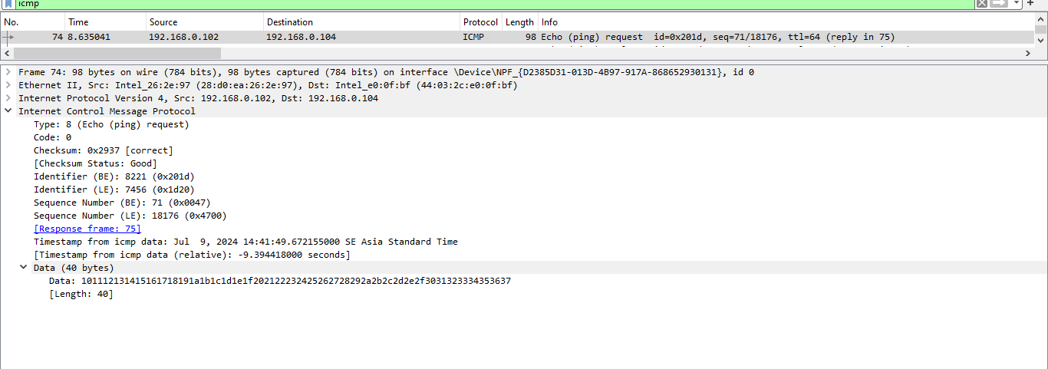

Through the process of analyzing the packet along with the icmp test of the ping command, it was found that no error message occurred.

Perform a successful icmp packet to other devices:

The icmp Source package 192.168.0.104 to Destination 192.168.0.69 (web01.com) succeeds.

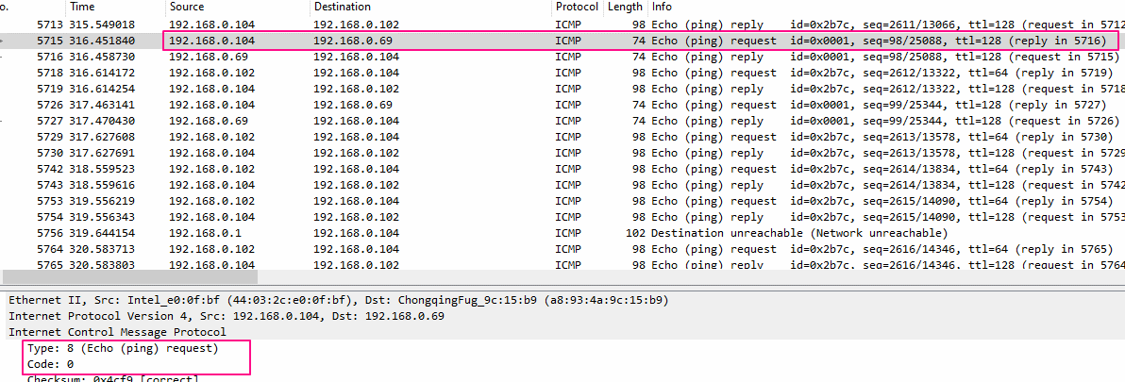

ICMP packets between 192.168.0.104 and 192.168.0.103 indicate a successful network connection between them.

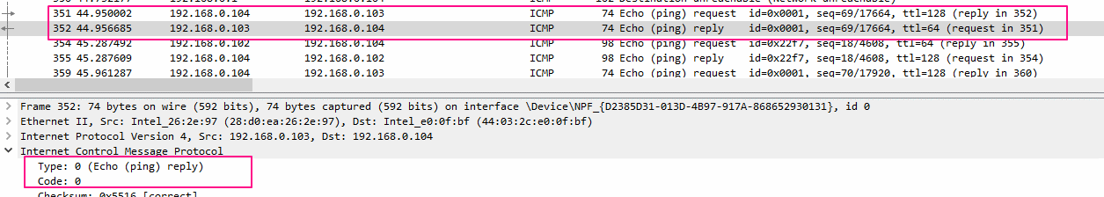

Testing the connection to the DNSserver (192.168.0.32) shows a successful connection.

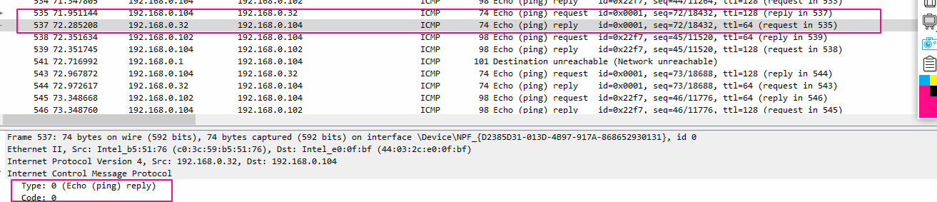

**Conclusions and reviews:**

The devices of the network lab model work normally, connected to each other. If any errors occur, continue to send ICMP packets to diagnose the network.

4.1.2 TCP packet analysis

**Purpose:** Check the TCP connection communication between the client and the server service. Thereby considering whether TCP is set up properly or not. There is a possibility of SYN flood attacks or abnormal states.

**Analyze:**

Perform 192.168.0.102 and 192.168.0.69 (web server) address filtering based on connection through TCP protocol.

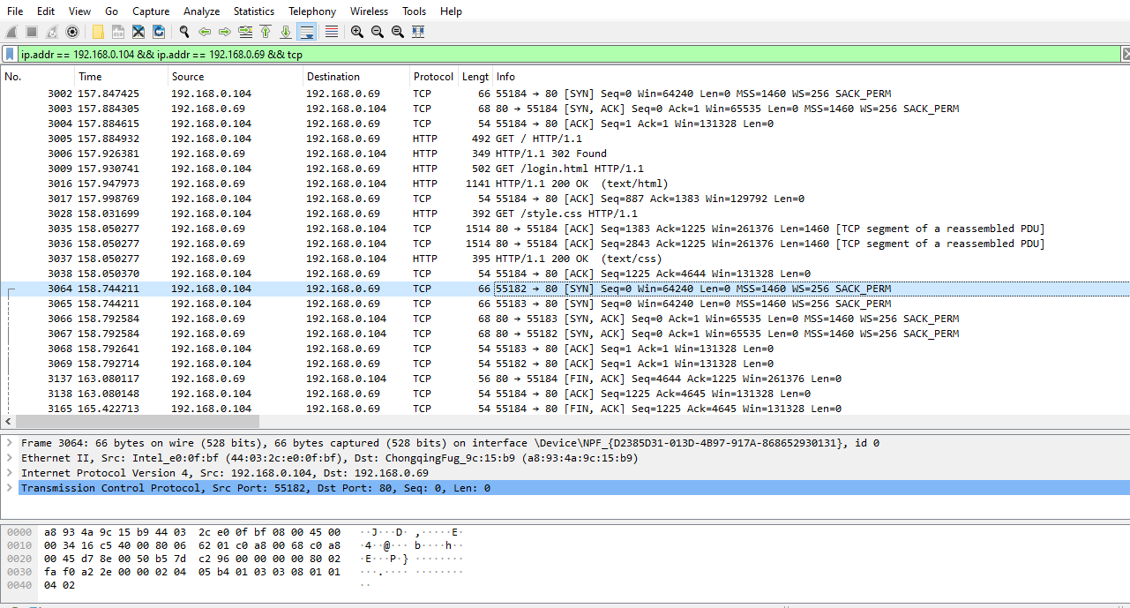

**TCP connection setup process**:

A TCP connection between the client and the server goes through a three-step handshake process.

B1) The client sends the connection setup to the server. It sends a syn segment to the server informing the server that the client has started communicating and with the order number in which it started the segment. Send SEQ=X

B2) The server responds to the customer's request with the SYN+ACK signal blocks set. ACK acknowledgment denotes the shard response it receives, and SYN denotes with the order number in which it is likely to start the shard.send (seq= y, ack=x+1)

B3) The client acknowledges the server's response and both establish a reliable connection and they will start transmitting the actual data. send (ack=y+1)

At client port: 55184 server port: 80. Consider packets No.3002 to No.3005.

Packet No.3002 client sends a connection request to server [SYN] seq=0.

Packet No.3003 indicates a response requesting the server to send [SYN, ACK] seq=0, ack=1 to the client.

Packet No.3004 acknowledges the packet sending response [ACK] seq=1,seq=1 both establish a reliable connection.

Packet No.3005 indicates that after the TCP connection was successful. Applications use the http protocol to access resources.

After successfully establishing communication, the client and server still send [ACK] to maintain the connection in packets No.3017, No.3035, No.3036, No.3038.

**Disconnect process:** Both parties send the [FIN,ACK] packet requesting a disconnect from each side. Both parties confirm that they have received the disconnect request via packet sending [ACK].



Packet No.3137: Server(192.168.0.69) sends packet [FIN, ACK] to client(192.168.0.04) requesting a disconnection.

Packet No.3138: Client sends [ACK] to the server confirming that a disconnect request has been received.

Packet No.3165: The client sends a packet [FIN,ACK] to the server requesting a disconnection.

Packet No.169: The resend server [ACK] acknowledges that a disconnect request has been received.

The disconnect process was successful.

**Conclusion & Reviews:**

The analysis results show that the TCP setup and disconnection process took place normally. Although it can be seen that in addition to TCP connections over port 55184 on the client and port 80 on the server, there are other connections 55182-80 and 55183-80 that may cause such multi-threaded connections to not affect network performance in this analysis.

The traffic was not abnormal, there was no SYN Flood attack. Recognizing this attack on the fact that a large amount of TCP SYN is sent to the target server and causes resource depletion, the server denies service. It can be fixed, if you notice that the amount of traffic sending syn tcp to the server is too much, use a firewall to limit the syn packet traffic from 1 IP address.

4.1.3 HTTP Protocol Analysis

It is a popular data transmission protocol used to transmit and display resources on the web. The security features of http websites are inferior to websites that use https.

**Purpose:** How the http protocol works is happening. Check and exploit the contents of the package using the http protocol. Analyze common factors to make judgments about the content analyzed.

Client accesses the web browser. The web browser relies on the url in the address bar and sends a connection request to the server. The server complains about an html source code file. Web browsers analyze the display of web page content if they have links to other web objects such as images, audio, etc,... It in turn sends messages to request those messages. Where the resource lies it will send there. The above explanation is analyzed in the following section:

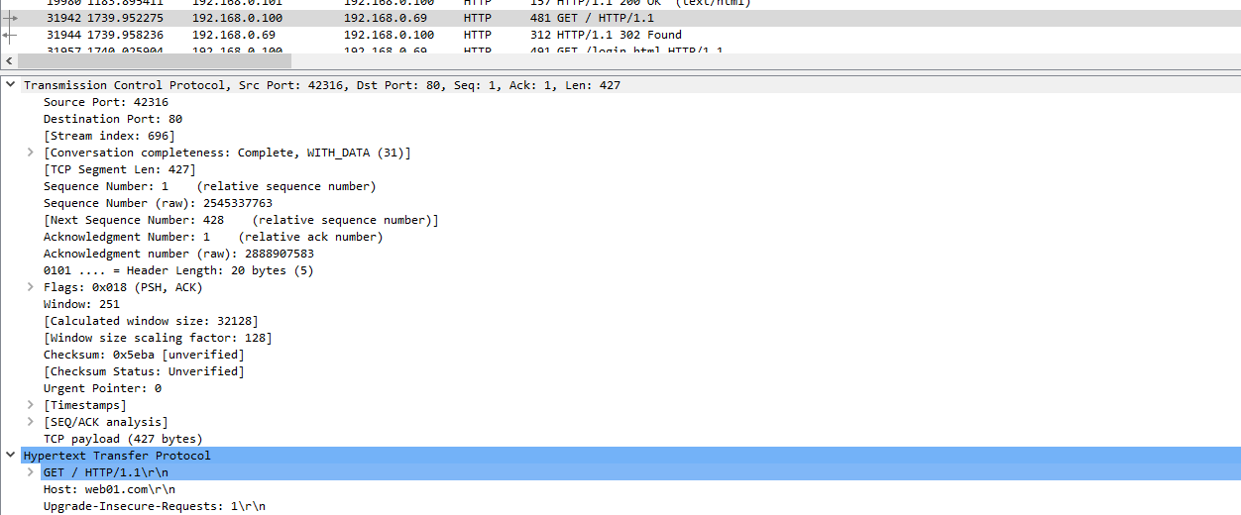Packet No.31942 shows that packets are sent after establishing client port: 42316, server:80 Host from web01.com. Deduce ip 192.168.0.100 is accessing web01.com.

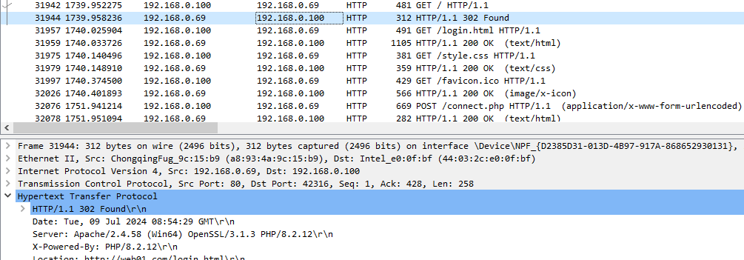

The 302 Found status code is returned in the first part of the HTTP response. This status code informs that the requested resource has been found and that the client needs to take a redirect action.

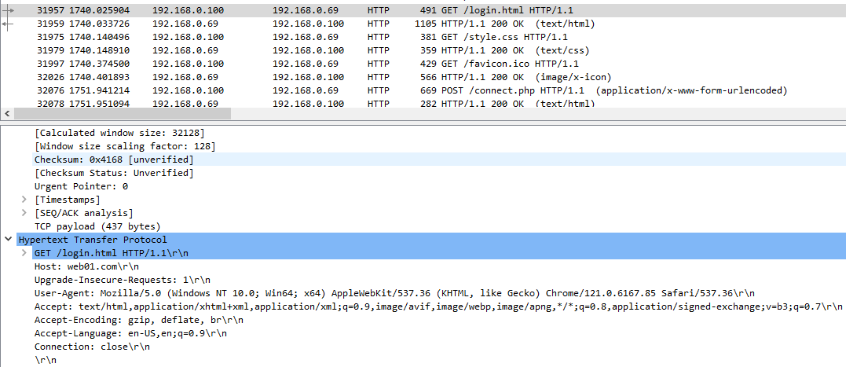

An HTTP request from the client to the server to request login.html resources. This request is made using the GET method in HTTP version 1.1.

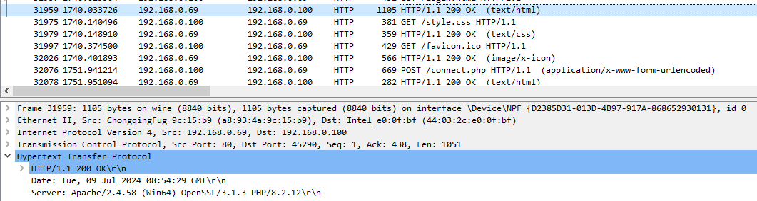

The status code "200 OK" indicates that the GET request for login.html resource has been successfully processed by the server, and the contents of this resource are returned in the body of the response.

Resource requests from the client via the GET method to the server. The server responds to the requested resources.

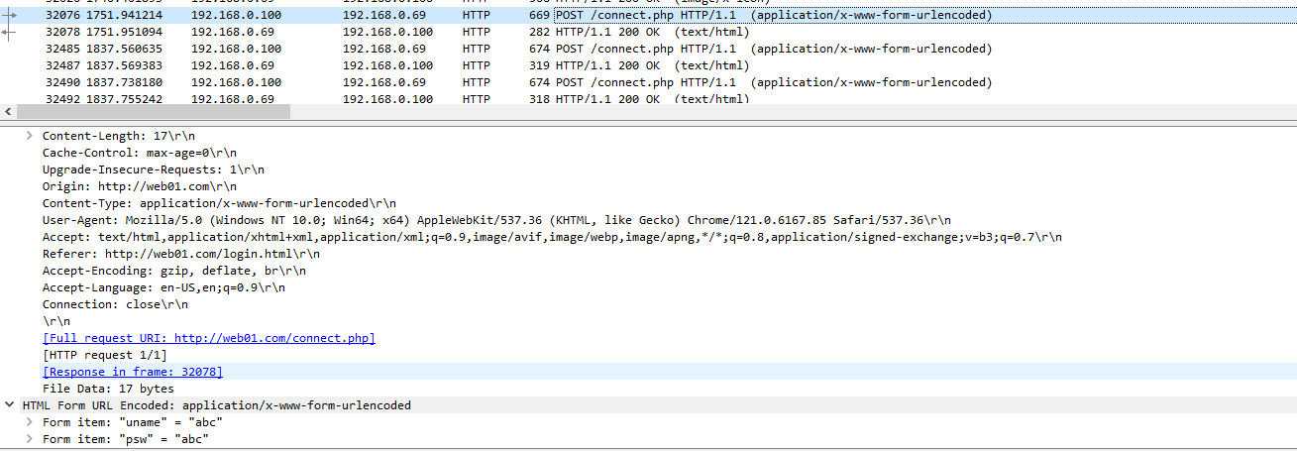

This request client uses the POST method to send data to the server at the /connect.php endpoint. The data submitted is application/x-www-form-urlencoded, meaning that the data is encoded as a key-value pair, similar to data from an HTML form.

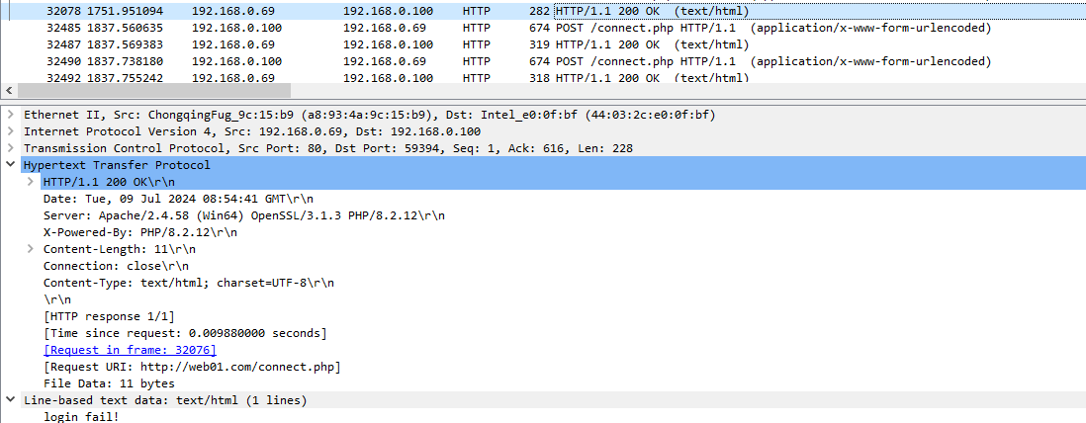

**The result of the server is "login fail"!**

Notice:

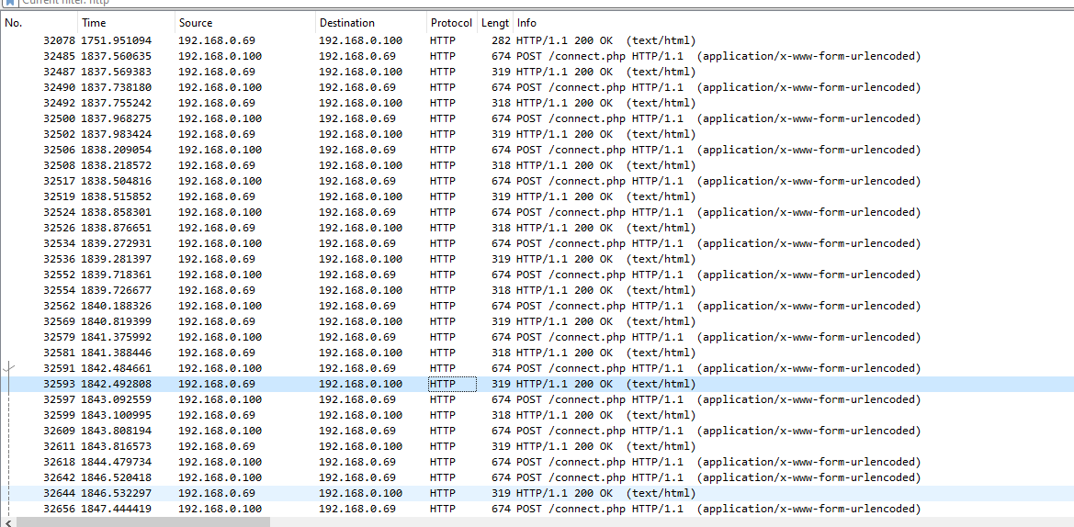

There is a spam that uses the POST method to the server.

**Conclusions and reviews:**

Using unsafe http can expose the information being sent. Such as passwords and passwords are entered.

Frequency of POST requests: If there are a lot of POST requests sent out in a short period of time, this may indicate that a brute-force attack is underway.

It is recommended to use the https protocol for better security mechanisms.

4.2 Python + Wireshark Automated Analysis

Install the pyshark library library to parse the pcapng file.

pip install pyshark

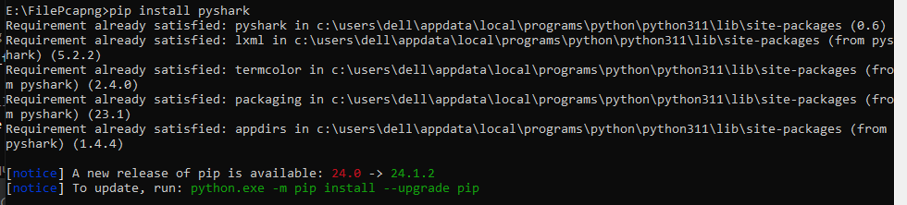

Based on static analysis with Wireshark to write process optimization code.

**Algorithm idea:**

For the purpose of checking whether the connection process of src and dst has changed status. Eliminate duplicate data for fast, concise analysis.

**Result:** shows that the output is as expected.

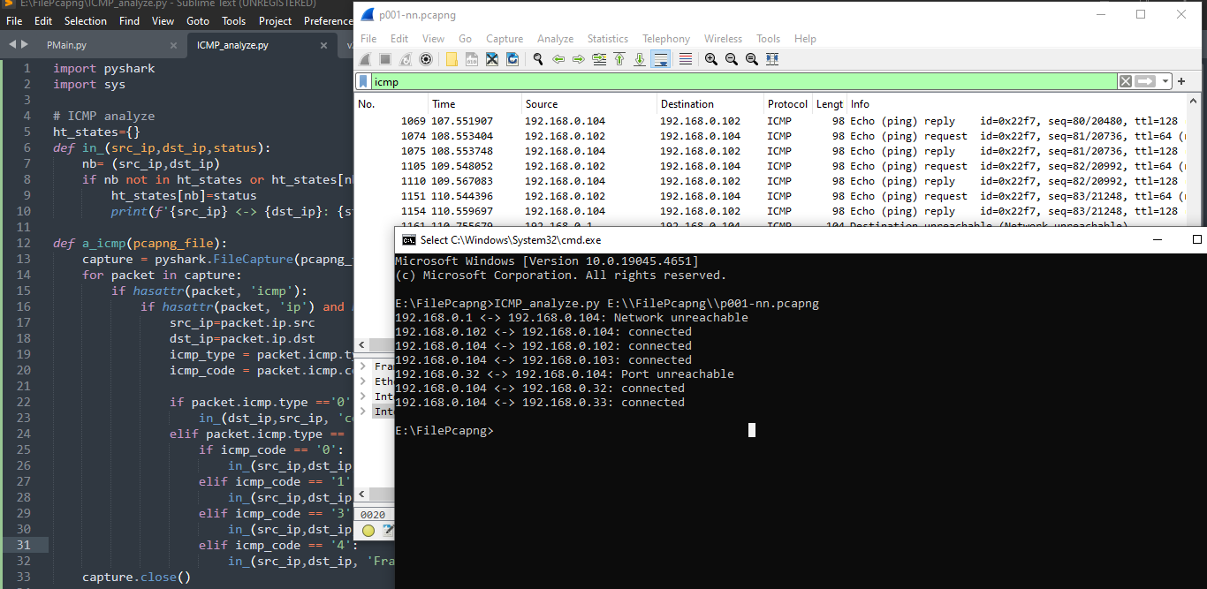

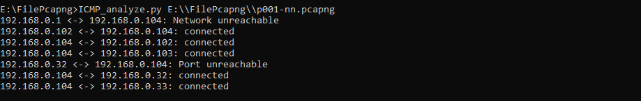

The address 192.168.0.1 is the gateway of the router. The fact that there is no recruitment on 192.168.0.104 is true due to 2 IP addresses on the same network. Devices can communicate with each other without router intervention.

Connection from source 192.168.0.102 to 192.168.0.104 was successful. The success message is based on the idea of ping order analysis.

Connection from 192.168.0.104 to 192.168.0.102, 192.168.0.103 successfully.

Connections from 192.168.0.32 to 192.168.0.104 port unreachable message indicate that the packet error message from the source could not reach the destination.

Optimizing the analysis process is useful if the volume to be analyzed is large.

**Automated attack traffic analysis:**

**Algorithm idea:**

Use analytical cues to come up with algorithmic conditions.

Algorithm formation information:

Packet No.24754 detected an xss attack, based on this event "%3Cscript%3Ealert%281%29%3C%2Fscript%3E" and then encrypted it to determine whether the encrypted data was xss related or not.



Package No.22032 was detected using the sqlmap tool to attack Sql Injection. It is known here that the User-Agent has information about the tool used.

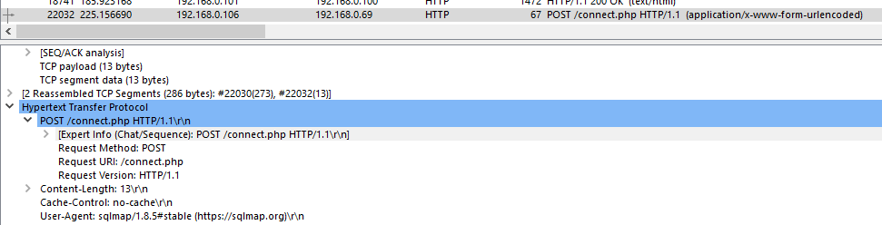

Through the analysis data, the direction of analysis, and the way of analysis form the analysis algorithm. Used for the purpose of simplifying and optimizing analysis work. It can be developed in the direction of AI machine learning to analyze quickly and efficiently, meet the incident response time.

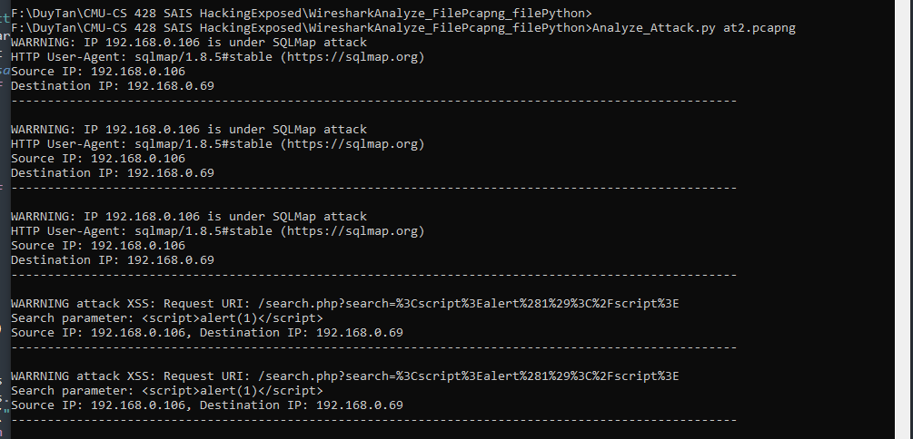

Running the attack analysis program, you can see that the at2.pcang file is a file containing the wireshark packet captured. There are 3 notifications about the possibility of a sql attack using the sqlmap tool. There are 2 notifications about xss attacks.

**Validate the correct code using the at2.pcang file:**

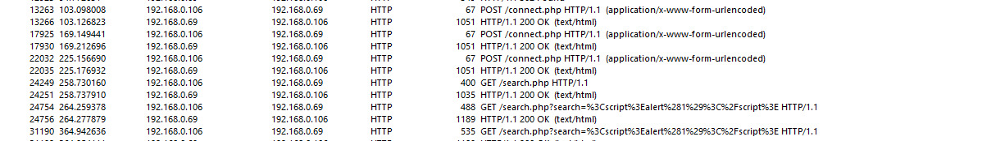

4.3 Detect traffic attacks.

4.3.1 XSS (Cross-Site Scripting) Attack Detection.

Information obtained: IP address 192.168.0.106 is requesting to server 192.168.0.69 using http protocol with GET request

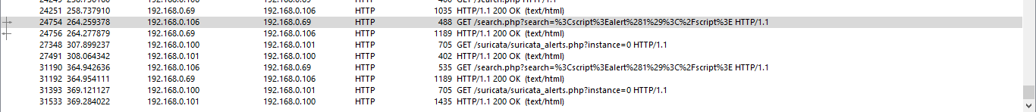

A more detailed analysis shows:

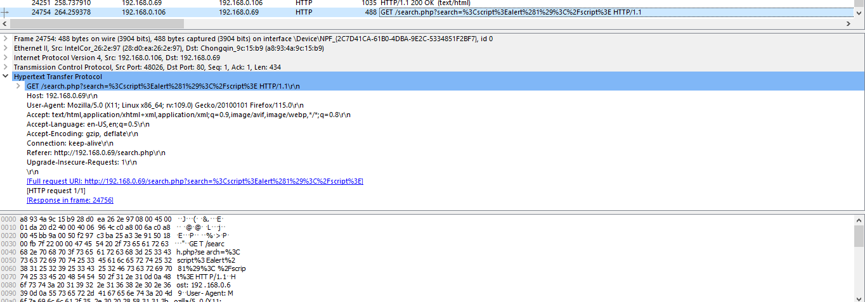

At the seach parameter:

Encryption value url: “%3Cscript%3Ealert%281%29%3C%2Fscript%3E”

Decrypt:

“%3Cscript%3E” : “<script>”,

“alert%281%29” : “alert(1)”,

“%3C%2Fscript%3E” : “</script>”

Complete encryption: “<script>alert(1)</script>”

**Conclude:**

The attacker is attempting to insert a piece of JavaScript code into the "search" parameter in the GET request. If the server does not properly process and inject this value into the website without checking or re-encoding, this code snippet will be executed on the user's browser, resulting in the display of an alert dialog with a value of 1.

4.3.1 SQL injection attack detection:

Traffic information obtained by wireshark:



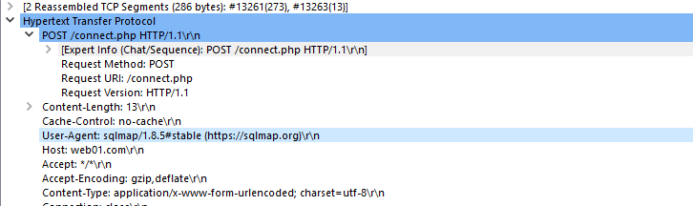

You can see Uer-Agent: sqlmap

**Conclude:**

In this packet, it can be seen that the data generated from the sqlmap tool uses the POST method of the http protocol sent to the web.com server. The sqlmap tool allows for automation of the process of detecting and exploiting SQL Injection vulnerabilities

web01.com server is attacked by sql injection.

PART5: PROPOSE SOLUTIONS AND REMEDIES.

**System Upgrade:**

**Firewall Deployment:** configure with powerful firewall rules to filter and control traffic between the intranet and the Internet, Enable intrusion detection and prevention in PFSense to detect and block potential attacks.

**DNS servers:** implement DNSSEC - Domain Name System Security Extensions to validate DNS responses and prevent modification.

Update the server and related applications to use the patch. Deploy WAFs web firewalls to combat common attacks such as SQL injection and cross-site scripting (XSS).

Use malicious protocols such as WPA2 or WPA3 to protect wireless routers. Implement MAC address filtering and disable SSID broadcasting to enhance wireless network security.

**For users:**

Educate users about good security practices, including identifying scams and adhering to the company's security policies.

Organize regular security training sessions to keep employees updated on emerging threats.

**Evaluate security updates regularly and periodically.**

**Incident Response Planning:**

Develop and maintain an incident response plan that specifies procedures for detecting, responding to, and recovering from security incidents.

Check your incident response plan regularly through simulation exercises to ensure readiness.

PART6: CONCLUDE

Our team achieved the set goals by simulating attacks on a web server with security vulnerabilities. Throughout this process, we recorded the damages and traces left behind, then proceeded to analyze the logs and network traffic to identify the weak points of the attacked system. These attacks helped us gain a deeper understanding of how hackers can exploit vulnerabilities, thereby pinpointing specific weaknesses in the system's security architecture. This process not only provided extensive knowledge about security but also gave us a practical perspective on how attacks can cause significant damage.

From these findings, we proposed effective remediation and prevention solutions to enhance the system's security. First, we implemented measures to patch software vulnerabilities and update to the latest versions of the operating system and related applications. Next, we applied monitoring mechanisms and early warning systems to detect abnormal behaviors in network traffic. Finally, we suggested raising awareness and training employees about cybersecurity to minimize the risks from phishing attacks and social engineering. These measures will help prevent similar attacks in the future and ensure the safety of the entire system's information, thereby increasing the security and reliability of the web server.

PART 7: REFLECTION

**Contribution of team members:**

|  |  |  |
| --- | --- | --- |
| **Name of Member** | **% of contributions** | **Task** |
| Chu Van An | 17% | Firewall PFsense |
| Tran Van Duc | 17% | Network Analyzer (to analyze network traffic) |
| Pham Ho Anh Dung | 17% | Attack |
| Luong Vu Anh Nga | 17% | Dns 1&2 |
| Tran Thi Thanh Thuy | 17% | SIEM |
| Dang Ngoc Xuan Tri | 15% | Webserver, Vulnerable |

ADDENDUM

The wireshark packet auto-analysis code captures algorithmic ideas based on static analysis using wireshark software.

**ICMP_analyze.py**

import pyshark

import sys

# ICMP analyze

ht_states={}

def in_(src_ip,dst_ip,status):

nb= (src_ip,dst_ip)

if nb not in ht_states or ht_states[nb]!= status:

ht_states[nb]=status

print(f'{src_ip} <-> {dst_ip}: {status}')

def a_icmp(pcapng_file):

capture = pyshark.FileCapture(pcapng_file, display_filter='icmp')

for packet in capture:

if hasattr(packet, 'icmp'):

if hasattr(packet, 'ip') and hasattr(packet.icmp, 'type'):

src_ip=packet.ip.src

dst_ip=packet.ip.dst

icmp_type = packet.icmp.type

icmp_code = packet.icmp.code if hasattr(packet.icmp, 'code') else None

if packet.icmp.type =='0':

in_(dst_ip,src_ip, 'connected')

elif packet.icmp.type == '3':

if icmp_code == '0':

in_(src_ip,dst_ip, 'Network unreachable')

elif icmp_code == '1':

in_(src_ip,dst_ip, 'Host unreachable')

elif icmp_code == '3':

in_(src_ip,dst_ip, 'Port unreachable')

elif icmp_code == '4':

in_(src_ip,dst_ip, 'Fragmention Needed and Do not Fragment was set')

capture.close()

def main():

""" read files

pcapng_file = 'E:\\FilePcapng\\p001-nn.pcapng'

a_icmp(pcapng_file)

"""

#read from command line arguments

a_icmp(sys.argv[1])

if __name__ == "__main__":

main()

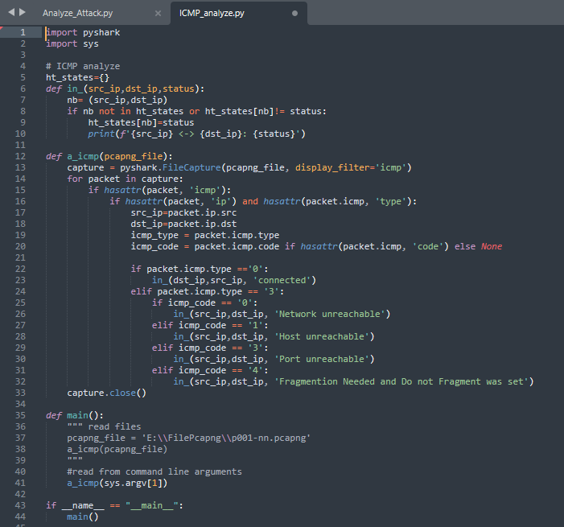

**Analyze_Attack.py:**

import pyshark

import sys

from urllib.parse import unquote

def analyze_attack(pcap_file):

fc = pyshark.FileCapture(pcap_file, display_filter='http')

for packet in fc:

if hasattr(packet, 'http'):

if hasattr(packet.http, 'user_agent') and 'sqlmap' in packet.http.user_agent.lower():

print(f"WARRNING: IP {packet.ip.src} is under SQLMap attack")

print(f"HTTP User-Agent: {packet.http.user_agent}")

print(f"Source IP: {packet.ip.src}")

print(f"Destination IP: {packet.ip.dst}")

print("-"*100+ "\n")

if hasattr(packet.http, 'request_uri') and '/search.php' in packet.http.request_uri:

search_param = packet.http.request_uri.split('?search=')[-1]

decoded_search_param = unquote(search_param)

if '<script>' in decoded_search_param:

print(f"WARRNING attack XSS: Request URI: {packet.http.request_uri}")

print(f"Search parameter: {decoded_search_param}")

print(f"Source IP: {packet.ip.src}, Destination IP: {packet.ip.dst}")

print("-"*100+"\n")

fc.close()

#Main

def main():

import sys

if len(sys.argv) != 2:

print("Usage: python analyze_attack.py <pcap_file>")

return

pcap_file = sys.argv[1]

analyze_attack(pcap_file)

if __name__ == "__main__":

main()

#luvim

